|  |  |
| --- | --- |
|  | **MINISTRY OF EDUCATION AND TRAINING** |

FPT UNIVERSITY

**DOCUMENT REPORT**

**Engineer Grab System**

|  |  |
| --- | --- |
| **Group** | |
| **Group members** | Đỗ Ngọc Hữu - SE130557  Từ Quang Huy - SE130537  Thân Nhật Trường - SE130426 |
| **Supervisor** | Lại Đức Hùng |
| **Ext. Supervisor** | N/A |
| **Project Code** | N/A |

# Table of Contents

Table of Contents 2

Definitions, Acronyms, and Abbreviations 3

A. Introduction 3

1. Project Information 3

2. Introduction 4

3. Current Situation 4

4. Problem Definition 4

5. Proposed Solution 5

5.1. Feature functions 5

5.2. Advantages and Disadvantages 5

6. Functional Requirements 5

7. Role and Responsibility 6

B. Software Requirements Specification 7

1. System Overview Use Case 7

2. List of Use Case 8

2.1 <Quest> Overview Use Case 8

2.2 <Authorized User> Overview Use Case 17

2.3 <Customer> Overview Use Case 30

2.4 <Engineer> Overview Use Case 55

2.5 <Admin> Overview Use Case 75

C. Database Design 91

1. Entity relationship diagram (ERD) 91

2. Database diagram 92

3. Query command 92

3.1 Query command 1 92

3.2 Query command 2 93

3.3 Query command 3 93

3.4 Query command 4 93

3.5 Query command 5 94

D. Survey information 94

8. Customer survey 94

9. Engineer survey 99

# Definitions, Acronyms, and Abbreviations

|  |  |
| --- | --- |
| **Name** | **Definition** |
| CV | Curriculum Vitae |
| URL | Uniform Resource Locator |
| EGS | Engineer Grab System |

# A. Introduction

## Project Information

* Project name:  **Engineer grab system**
* Start Date: **March 20th, 2020**
* End Date: **--**

## Introduction

In this document, we introduce a solution for you about finding an engineer. Today, finding the engineers is no longer difficult but there are still some problems such as quality, prestige, price or inconvenience in traveling. Understanding those things, we have created the "Engineer grab system". So what is the "Engineer grab system"? The "Engineer grab system" is the most convenient and efficient way to connect engineers with customers.

In the "Engineer grab system", we build a standardized community of engineers to provide our customers with the best service, ensuring the rights of engineers and customers.

A team of qualified engineers from the style, behavior to the code of conduct are always ready to serve you anytime, anywhere.

Our application is a bridge to help customers and engineers can connect with each other more easily and conveniently.

## Current Situation

When machines, devices or household items are damaged, to find an engineer, customers often come to the company, repair store. So, sometimes customers have to go very far and take time. Moreover, finding a bad engineer will affect items as well as losing money. When engineers want to find customers or earn extra income through repairs, it becomes difficult when they can only be passive waiting for customers to come to the company, repair store or at home without being proactive.

With this application, the amount of time spent travel is greatly reduced, avoiding unexpected risks.

## Problem Definition

Below are disadvantages of the current situation:

* The repair cost cannot be calculated: With some damaged items, customers won't know how much it will cost to repair. Therefore, they are often taken advantage of by bad engineers and take more money than they have to pay.
* Finding an experienced engineer is difficult: Customers who have damaged items will not know who can repair the items without getting damaged again. So they have a lot of risks when looking for an engineer they do not know.
* Finding for engineers around is very time-consuming: Customers will usually look for engineers or repair stores around them. That makes this search very time-consuming.
* Engineers can hardly find customers: Typically, engineers can only work at companies, repair stores or at home. When they want to earn more income or find customers, this will make it difficult for them to be proactive in finding customers.

## Proposed Solution

Our proposed solution is to build a system called the “Engineer grab system”. The system is a bridge between customers who have damaged items and approved engineers. Customers can post the request about their problem, from which engineers can find it and go to the place to fix it. In addition, our system can filter out repair requests by the district or city, which can reduce the travel time for the engineers.

EGS is an app application with following functions:

### Feature functions

* Add a new request: Customers who have damaged items can post a repair request. An admin will verify those requests and upload them to the system.
* Submit the profile: Engineers after reading the request details, will be able to submit their profile to the customers for approval.
* Make a deal: After the customer accepts an engineer's request, the customer and the engineer make a deal. So the engineer will go to the request address to repair the customer's damaged items.

### Advantages and Disadvantages

* **Advantages:**
* Customers and Engineers make the deal quickly and easily.
* Customers choose the appropriate engineer.
* Customer decrease travel time.
* Engineers increase income.
* Engineers find the customers easily.
* There are promotions for the customers and the engineers.
* **Disadvantages:**
* The requests are difficult to guarantee accuracy.
* The requests are difficult to guarantee to be repaired.
* Repair costs cannot be calculated.

## Functional Requirements

Function requirements of the system are listed as below:

* Quest component:
* Login
* Register
* Customer component:
* Search the request
* Search the others
* Rate the engineer
* Feedback the engineer
* Manage the request
* Manage the deal
* Manage the promotion
* Manage own profile
* Engineer component:
* Search the request
* Search the others
* Submit the profile
* Manage the deal
* Manage the promotion
* Manage the wallet
* Manage own profile
* Admin component:
  + Search the request
  + Search the others
  + Manage the user
  + Manage the promotion
  + Manage the wallet
  + Manage the Transaction
  + Manage own profile

## Role and Responsibility

|  |  |  |  |  |
| --- | --- | --- | --- | --- |
| **No** | **Full Name** | **Role** | **Position** | **Contact** |
| 1 | Lại Đức Hùng | Project Supervisor | Supervisor | Hungld@fpt.edu.vn |
| 2 | Đỗ Ngọc Hữu | Developer | Leader | Huudnse130557@fpt.edu.vn |
| 3 | Thân Nhật Trường | Developer | Member | [Truongtnse130426@fpt.edu.vn](mailto:Truongtnse130426@fpt.edu.vn) |
| 4 | Từ Quang Huy | Developer | Member | Huytqse130537@fpt.edu.vn |

*Table 1: Roles and Responsibilities*

# B. Software Requirements Specification

## 1. System Overview Use Case

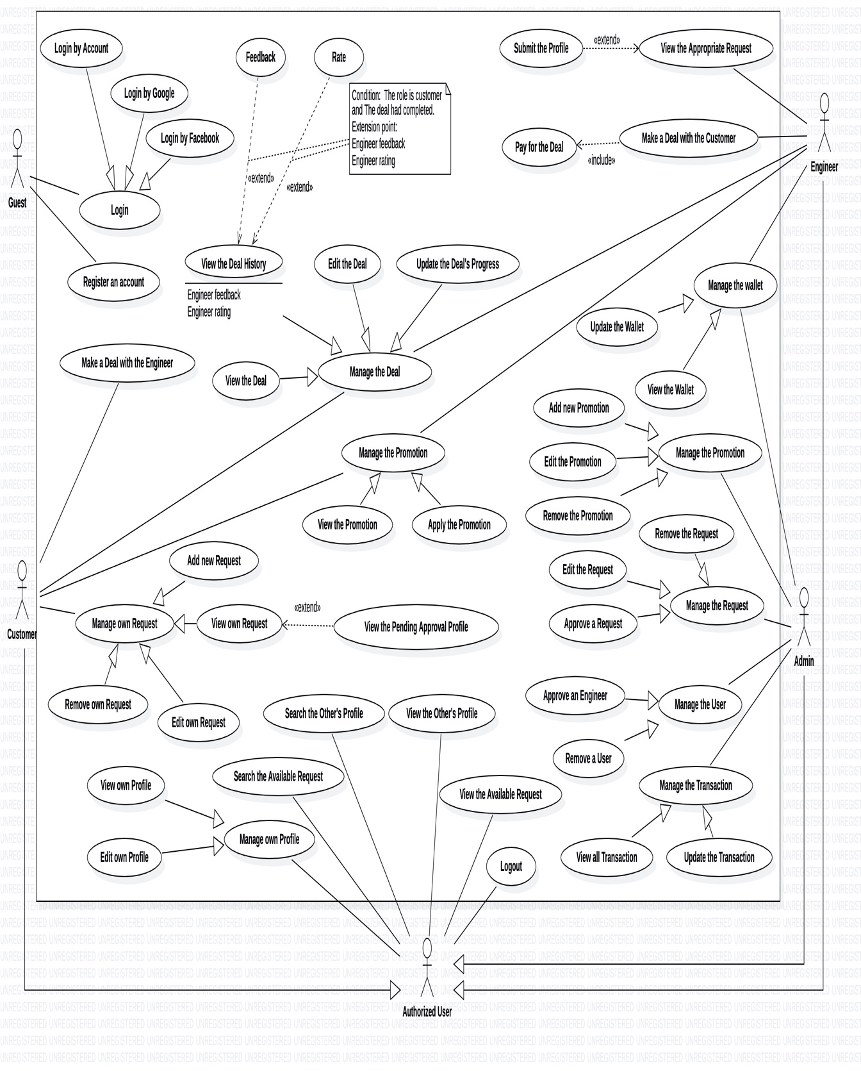

*Figure 1- System Overview Use Case Diagram*

## 2. List of Use Case

### 2.1 <Quest> Overview Use Case

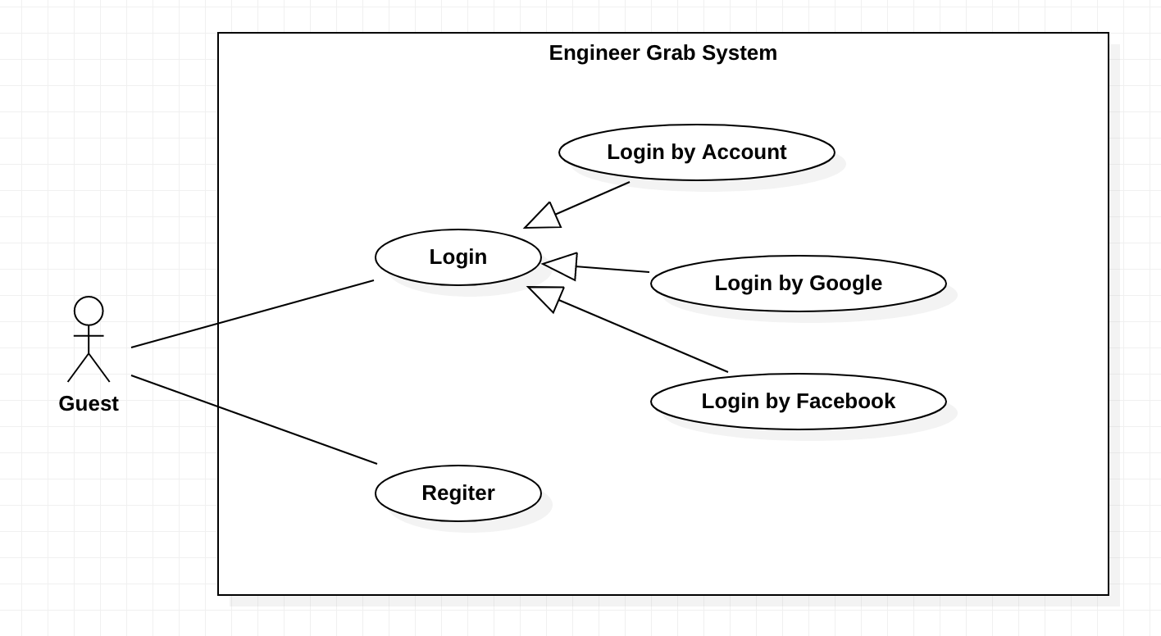

*Figure 2- <Quest> Overview Use Case*

#### 2.1.1 <Quest>Login by Account

**Use case diagram**

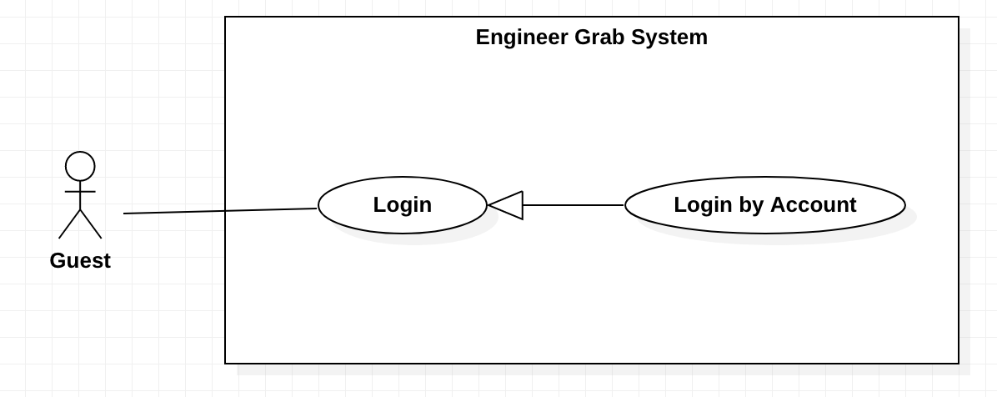

*Figure 3- <Quest> Login by account*

**Use Case Specification**

|  |  |  |  |
| --- | --- | --- | --- |
| **USE CASE – Engineer Grab System** | | | |
| **Use Case No.** | EGS-01 | **Use Case Version** | 1.0 |
| **Use Case Name** | Login by Account | | |
| **Author** | HuyTQ | | |
| **Date** | 20/02/2020 | **Priority** | Normal |
| **Actor:**  - Guest.  **Summary:**  - This use case allows the guest to login the system by account.  **Goal:**  - Guest can login to the system by account.  **Triggers:**  - Guest clicks on the “Login” button.  **Preconditions:**  - Guest is on the Home page.  **Postconditions:**  - **Success**: Guest logins to the system successfully.  - **Fail**: System shows the error message.  **Main Success Scenarios:**   |  |  |  | | --- | --- | --- | | **Step** | **Actor Action** | **System Response** | | 1 | Guest clicks on the “Login” button on the navigation menu. | System shows the form:  + Username: input.  + Password: input. | | 2 | Guest inputs the fields. |  | | 3 | Guest clicks on the “Login” button. | System shows the message: “Login successful”.  [Exception 1, 2, 3] |   **Alternative Scenarios:** N/A  **Exceptions:**   |  |  |  | | --- | --- | --- | | **No** | **Actor Action** | **System Response** | | 1 | The username is blank. | System shows the message: “The username is required”. | | 2 | The password is blank. | System shows the message: “The password is required”. | | 3 | The account is not available. | System shows the message: “Invalid username or password”. | | 4 | Internet problem. | System shows the message:" The system is busy" when the internet is lost. |   **Relationships:** N/A  **Business Rules:**  - Password was converted before being sent to server.  - After login to the system, guest will be redirected to specific view based on their role on the system:  + If the role is the Admin, the system will display to the Admin page.  + If the role is the Engineer, the system will display to the Home page.  + If the role is the Customer, the system will display to the Home page. | | | |

*Table 2 - <Quest> Login by account*

#### 2.1.2 <Quest>Login by Google

**Use Case Diagram**

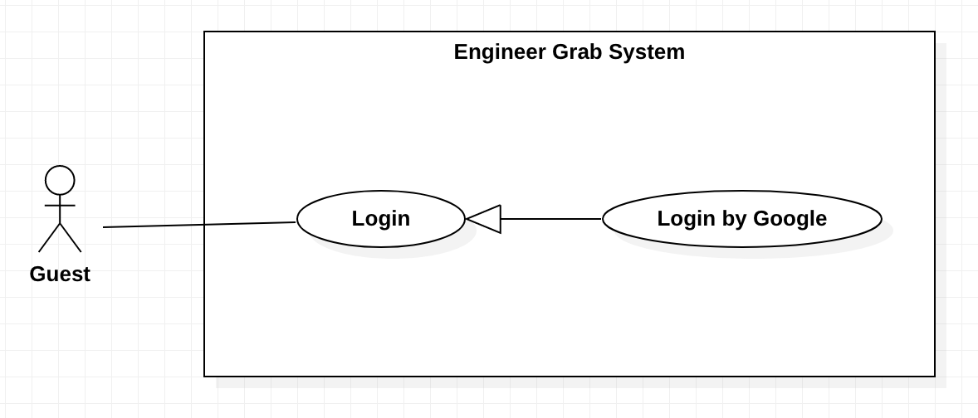

*Figure 4 - <Quest> Login by Google*

**Use Case Specification**

|  |  |  |  |
| --- | --- | --- | --- |
| **USE CASE – Engineer Grab System** | | | |
| **Use Case No.** | EGS-02 | **Use Case Version** | 1.0 |
| **Use Case Name** | Login by Google | | |
| **Author** | HuyTQ | | |
| **Date** | 20/02/2020 | **Priority** | Normal |
| **Actor:**  - Guest.  **Summary:**  - This use case allows the guest to login the system by Google account.  **Goal:**  - Guest can login the system by Google account.  **Triggers:**  - Guest clicks on the “Login by Google” button.  **Preconditions:**  - Guest is on the Login page.  **Postconditions:**  - **Success**: Guest login to the system successfully.  - **Fail**: System shows the error message.  **Main Success Scenarios:**   |  |  |  | | --- | --- | --- | | **Step** | **Actor Action** | **System Response** | | 1 | Guest clicks on the “Login by Google” button. | System shows the Google login form:  + Email: input  + Password: input | | 2 | Guest inputs the fields. |  | | 3 | Guest clicks on the “Login” button. | System shows the message: “Login successful”.  [Exception 1, 2, 3, 4] |   **Alternative Scenarios:** N/A  **Exceptions:**   |  |  |  | | --- | --- | --- | | **No** | **Actor Action** | **System Response** | | 1 | The email is blank. | System shows the message: “The email is required”. | | 2 | The password is blank. | System shows the message: “The password is required”. | | 3 | The account is not available. | System shows the message: “Invalid email or password”. | | 4 | Internet problem. | System shows message: "The system is busy" when the internet is lost. |   **Relationships:** N/A  **Business Rules:**  - After login to the system, guest will be redirected to specific view based on their role on the system:  + If the role is the Admin, the system will display to the Admin page.  + If the role is the Engineer, the system will display to the Home page.  + If the role is the Customer, the system will display to the Home page. | | | |

*Table 3 - <Quest> Login by Google*

#### 2.1.3 <Quest>Login by Facebook

**Use Case Diagram**

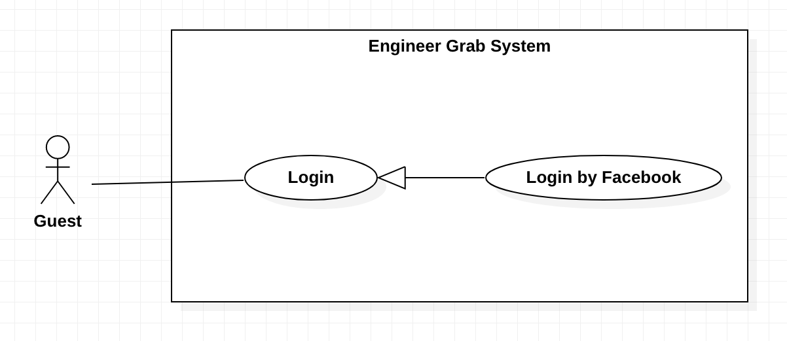

*Figure 5 - <Quest> Login by Facebook*

**Use Case Specification**

|  |  |  |  |
| --- | --- | --- | --- |
| **USE CASE – Engineer Grab System** | | | |
| **Use Case No.** | EGS-03 | **Use Case Version** | 1.0 |
| **Use Case Name** | Login by Facebook | | |
| **Author** | HuyTQ | | |
| **Date** | 20/02/2020 | **Priority** | Normal |
| **Actor:**  - Guest.  **Summary:**  - This use case allows the guest to login the system by Facebook account.  **Goal:**  - Guest can login to the system by Facebook account.  **Triggers:**  - Guest clicks on the “Login by Facebook” button.  **Preconditions:**  - Guest is on the Login page.  **Postconditions:**  - **Success**: Guest login to the system successfully.  - **Fail**: System shows the error message.  **Main Success Scenarios:**   |  |  |  | | --- | --- | --- | | **Step** | **Actor Action** | **System Response** | | 1 | Guest clicks on the “Login by Facebook” button. | System shows the Facebook login form:  + Username or phone number: input  + Password: input | | 2 | Guest inputs the fields. |  | | 3 | Guest clicks on the “Login” button. | System shows the message: “Login successful”.  [Exception 1, 2, 3, 4] |   **Alternative Scenarios:** N/A  **Exceptions:**   |  |  |  | | --- | --- | --- | | **No** | **Actor Action** | **System Response** | | 1 | The user name or phone number is blank. | System shows the message: “The username or phone number is required”. | | 2 | The password is blank. | System shows the message: “The password is required”. | | 3 | The account is not available. | System shows the message: “Invalid username or password”. | | 4 | Internet problem. | System shows message: “The system is busy" when the internet is lost. |   **Relationships:** N/A.  **Business Rules:**  - After login to the system, guest will be redirected to specific view based on their role on the system:  + If the role is the Admin, the system will display to the Admin page.  + If the role is the Engineer, the system will display to the Home page.  + If the role is the Customer, the system will display to the Home page. | | | |

*Table 4 - <Quest> Login by Facebook*

#### 2.1.4 <Quest>Register

**Use Case Diagram**

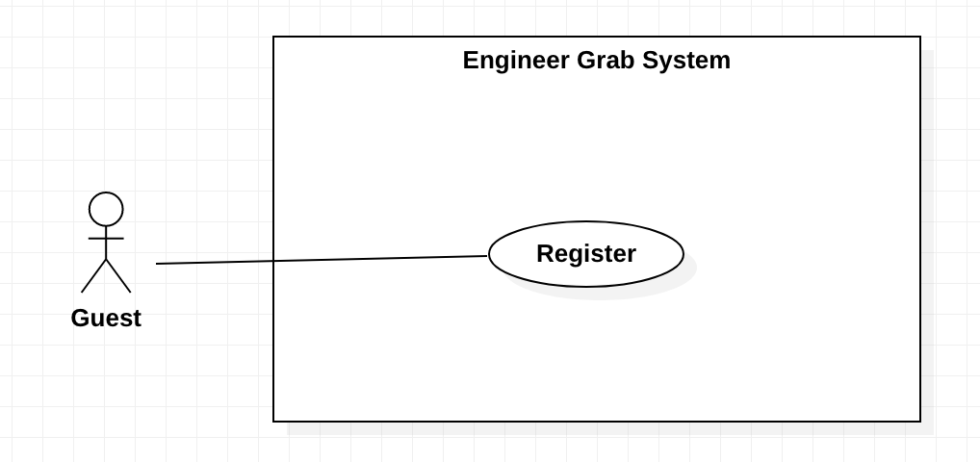

*Figure 6 - <Quest> Register*

**Use Case Specification**

|  |  |  |  |
| --- | --- | --- | --- |
| **USE CASE – Engineer Grab System** | | | |
| **Use Case No.** | EGS-04 | **Use Case Version** | 1.0 |
| **Use Case Name** | Register an account | | |
| **Author** | HuyTQ | | |
| **Date** | 20/02/2020 | **Priority** | Normal |
| **Actor:**  - Guest.  **Summary:**  - This use case allows the guest to register an account.  **Goal:**  - Guest can register an account.  **Triggers:**  - Guest clicks on the “Register” button.  **Preconditions:**  - Guest is on the login page.  **Postconditions:**  - **Success**: Guest registers successfully.  - **Fail**: System shows the error message.  **Main Success Scenarios:**   |  |  |  | | --- | --- | --- | | **Step** | **Actor Action** | **System Response** | | 1 | Guest clicks on the “Register an account” button. | System shows the form that includes:  + Username: input.  + Fullname: input  + Phone: input  + Email: input  + Sex: check box  + Address: input  + City: combobox  + District: combobox  + Identify card: image  + Password: input.  + Re-type password: input | | 2 | Guest inputs the fields. |  | | 3 | Guest clicks on the “Register” button. | System shows the message: “Register successful”.  [Exception 1, 2, 3, 4, 5, 6, 7, 8, 9, 10, 11] |   **Alternative Scenarios:** N/A  **Exceptions:**   |  |  |  | | --- | --- | --- | | **No** | **Actor Action** | **System Response** | | 1 | The username existed. | System shows the message: “The username existed”. | | 2 | The username includes 6 – 30 characters. | System shows the message: “The username includes 6 - 30 characters.” | | 3 | The full name includes 6 – 50 characters. | System shows the message: “The full name includes 6 - 50 characters.” | | 4 | The sex is not selected. | System shows the message: “The sex must be selected”. | | 5 | The requestor’s phone includes 10 – 12 digits. | System shows the message: “The requestor’s phone includes 10 – 12 digits.” | | 6 | The identify card is empty. | System shows the message: “The identify card is required”. | | 7 | Email does not follow format form: ^[^\s@]+@[^\s@]+\.[^\s@]+$ | Email must follow format: ^[^\s@]+@[^\s@]+\.[^\s@]+$ | | 8 | The address is blank. | System shows the message: “The address is required”. | | 9 | The district is not selected. | System shows the message: “The district must be selected.” | | 10 | The city is not selected. | System shows the message: “The city must be selected”. | | 11 | The password includes 6 – 30 characters | System shows the message: “The password includes 6 - 30 characters.” | | 12 | The re-type password does not match password. | System show the message: “The re-type password does not match password.” | | 12 | Internet problem. | System shows message "The system is busy" when the internet is lost. |   **Relationships:** N/A  **Business Rules:**  - Password was converted before being sent to server.  - Guest can register an account by Facebook or Google.  - A new account has “customer” role.  - After the register successful, system redirects to the login page. | | | |

*Table 5 - <Quest> Register*

### 2.2 <Authorized User> Overview Use Case

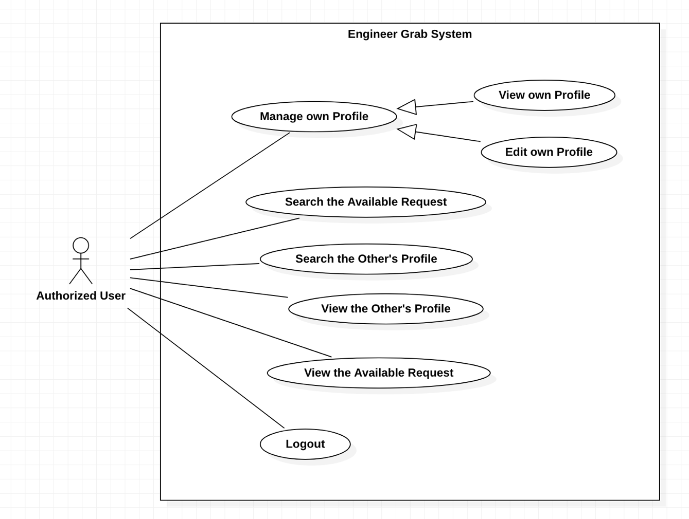

*Figure 7 - <Authorized User> Overview Use Case*

#### 2.2.1 <Authorized User> View Own Profile

**Use Case Diagram**

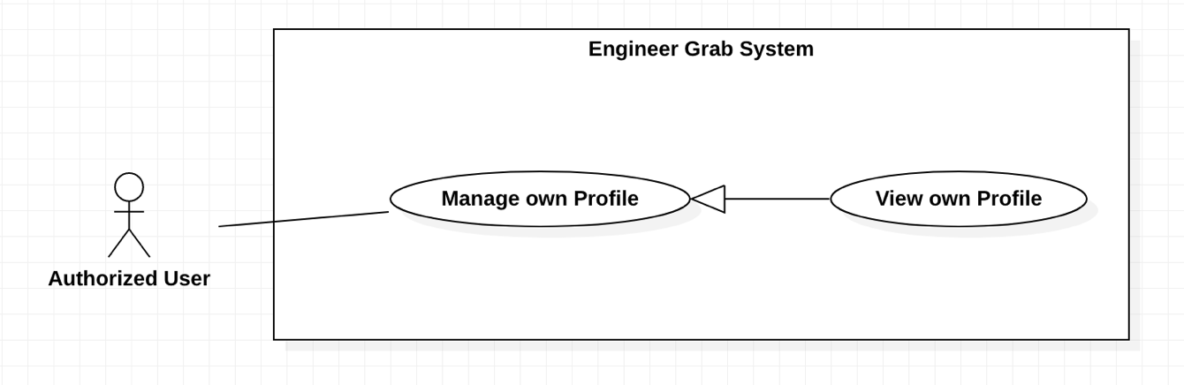

*Figure 8 - <Authorized User> View own Profile*

**Use Case Specification**

|  |  |  |  |
| --- | --- | --- | --- |
| **USE CASE – Engineer Grab System** | | | |
| **Use Case No.** | EGS-05 | **Use Case Version** | 1.0 |
| **Use Case Name** | View own Profile | | |
| **Author** | HuyTQ | | |
| **Date** | 25/02/2020 | **Priority** | Normal |
| **Actor:**  - Authorized user.  **Summary:**  - This use case allows the authorized user to view own profile.  **Goal:**  - Authorized user can view own profile.  **Triggers:**  - Authorized user clicks on the “Your Profile” button.  **Preconditions:**  - Authorized user must login to the system.  **Postconditions:**  - **Success**: Authorized user view own profile details successfully.  - **Fail**: System shows the error message.  **Main Success Scenarios:**   |  |  |  | | --- | --- | --- | | **Step** | **Actor Action** | **System Response** | | 1 | Authorized user clicks on the “Your Profile” button. | System shows the profile details that includes:  + Username  + Full name  + Sex  + Phone  + Identity Card  + Avatar  + Email  + Address  + Role name  + District  + City |   **Alternative Scenarios:** N/A  **Exceptions:**   |  |  |  | | --- | --- | --- | | **No** | **Actor Action** | **System Response** | | 1 | Internet problem. | System shows the message "The system is busy" when the internet is lost. |   **Relationships:** N/A  **Business Rules:**  - If role is engineer, the profile shows more details that includes:  + The wallet details  + Career  + Curriculum Vitae  + Experience year | | | |

*Table 6 - <Authorized User> View own Profile*

#### 2.2.2 <Authorized User> Edit Own Profile

**Use Case Diagram**

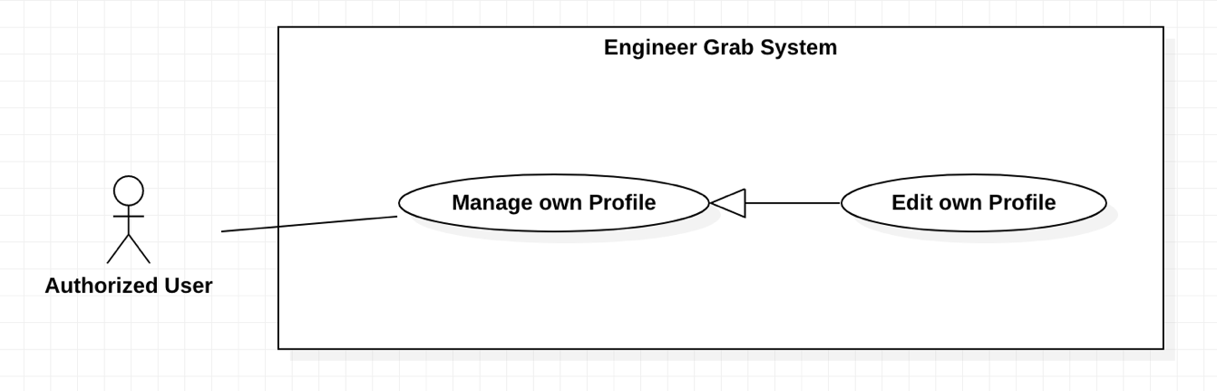

*Figure 9 - <Authorized User> Edit own Profile*

**Use Case Specifications**

|  |  |  |  |
| --- | --- | --- | --- |
| **USE CASE – Engineer Grab System** | | | |
| **Use Case No.** | EGS-06 | **Use Case Version** | 1.0 |
| **Use Case Name** | Edit own Profile | | |
| **Author** | HuyTQ | | |
| **Date** | 25/02/2020 | **Priority** | Normal |
| **Actor:**  - Authorized user.  **Summary:**  - This use case allows the authorized user to edit own profile.  **Goal:**  - Authorized user can edit own profile.  **Triggers:**  - Authorized user clicks on the “Edit Your Profile” button.  **Preconditions:**  - Authorized user must login to the system.  - Authorized user is on the personal profile page.  **Postconditions:**  - **Success**: Authorized user edits own profile successfully.  - **Fail**: System shows the error message.  **Main Success Scenarios:**   |  |  |  | | --- | --- | --- | | **Step** | **Actor Action** | **System Response** | | 1 | Authorized user clicks on the “Edit Your Profile” button. | System shows the form that includes:  + Full name: input  + Images: image  + Sex: check box  + Phone: input  + Avatar: image  + Email: input  + Address: input  + District: combobox  + City: combobox | | 2 | Authorized user inputs and selects the fields. |  | | 3 | Authorized user clicks on the “Save” button. | System shows the message:” Edit successfully”.  [Exception 1, 2, 3, 4, 5, 6, 7] |   **Alternative Scenarios:** N/A  **Exceptions:**   |  |  |  | | --- | --- | --- | | **No** | **Actor Action** | **System Response** | | 1 | The full name includes 6 – 50 characters. | System shows the message: “The full name includes 6 - 50 characters.” | | 2 | The images are empty. | System shows the message: “The images are required”. | | 4 | The requestor’s phone includes 10 – 12 digits. | System shows the message: “The requestor’s phone includes 10 – 12 digits.” | | 5 | The avatar is empty. | System shows the message: “The avatar is required”. | | 6 | Email does not follow format form: ^[^\s@]+@[^\s@]+\.[^\s@]+$ | Email must follow format: ^[^\s@]+@[^\s@]+\.[^\s@]+$ | | 7 | The address is blank. | System shows the message: “The address is required”. | | 8 | Internet problem. | System shows message "The system is busy" when the internet is lost. |   **Relationships:** N/A  **Business Rules:**  - After the authorized user had edited, system redirects to personal profile page. | | | |

*Table 7 - <Authorized User> Edit own Profile*

#### 2.2.3 <Authorized User> Search the Available Request

**Use Case Diagram**

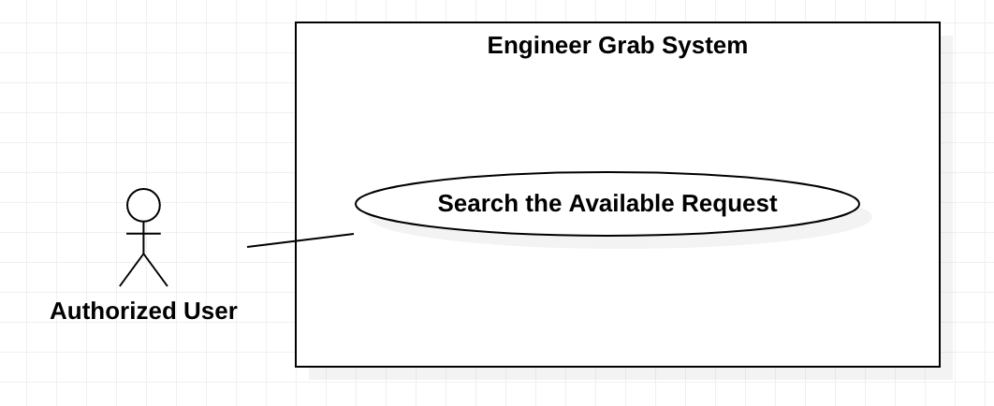

*Figure 10 - <Authorized User> Search the Available Request*

**Use Case Specifications**

|  |  |  |  |
| --- | --- | --- | --- |
| **USE CASE – Engineer Grab System** | | | |
| **Use Case No.** | EGS-07 | **Use Case Version** | 1.0 |
| **Use Case Name** | Search the Available Request | | |
| **Author** | HuyTQ | | |
| **Date** | 25/02/2020 | **Priority** | Normal |
| **Actor:**  - Authorized user.  **Summary:**  - This use case allows the authorized user to search the available requests.  **Goal:**  - Authorized user can search the available requests.  **Triggers:**  - Authorized user clicks on the “Search” button.  **Preconditions:**  - Authorized user must login to the system.  - Authorized user is on the home page.  **Postconditions:**  - **Success**: System shows the available requests successfully.  - **Fail**: System shows the error message.  **Main Success Scenarios:**   |  |  |  | | --- | --- | --- | | **Step** | **Actor Action** | **System Response** | | 1 | Authorized user inputs information into the “Search” box. |  | | 2 | Authorized user presses the “Enter” key or clicks on the “Search” button. | System shows the list of the available request’s details that includes:  + Title  + Content  + Created Time  + Request Time  + City  + District  + Service Details  + Promotion Details  + Image |   **Alternative Scenarios:** N/A  **Exceptions:**   |  |  |  | | --- | --- | --- | | **No** | **Actor Action** | **System Response** | | 1 | The search text is empty. | System shows the message: “The search text is required”. | | 2 | The list of the available requests is empty. | System shows the message: “No result”. | | 3 | Internet problem. | System shows the message "The system is busy" when the internet is lost. |   **Relationships:** N/A.  **Business Rules:**  - The requests that have “active” status show for the customer and engineer.  - The requests that have “new”, “active”, “deleted” and “canceled” status show for the admin.  - For the admin, the requests shows more the request’s details that include:  + Request ID  + Status  - The requests must be sorted by descending created time.  - The requests must be paging. | | | |

*Table 8 - <Authorized User> Search the Available Request*

#### 2.2.4 <Authorized User> Search the Other’s Profile

**Use Case Diagram**

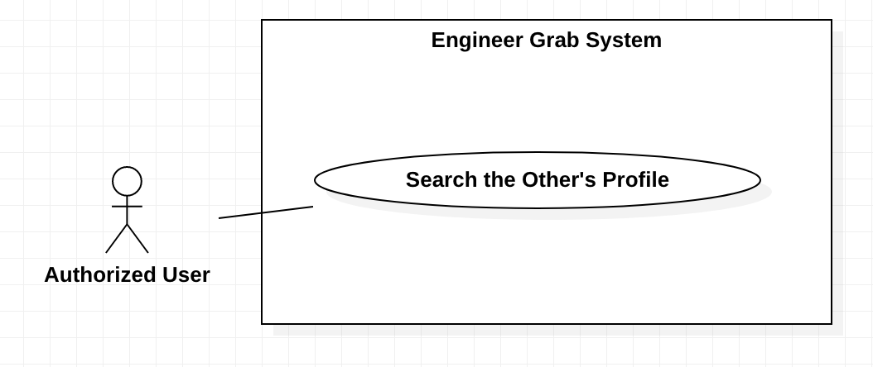

*Figure 11 - <Authorized User> Search the Other’s Profile*

**Use Case Specifications**

|  |  |  |  |
| --- | --- | --- | --- |
| **USE CASE – Engineer Grab System** | | | |
| **Use Case No.** | EGS-08 | **Use Case Version** | 1.0 |
| **Use Case Name** | Search the Other’s Profile | | |
| **Author** | HuyTQ | | |
| **Date** | 5/03/2020 | **Priority** | Normal |
| **Actor:**  - Authorized user.  **Summary:**  - This use case allows the Authorized user to search the other’s profile.  **Goal:**  - Authorized user can search the other’s profile.  **Triggers:**  - Authorized user clicks on the “Search” button.  **Preconditions:**  - Authorized user must login to the system.  - Authorized user is on the home page.  **Postconditions:**  - **Success**: System shows list of the other’s profile.  - **Fail**: System shows the error message.  **Main Success Scenarios:**   |  |  |  | | --- | --- | --- | | **Step** | **Actor Action** | **System Response** | | 1 | Authorized user inputs information into the “Search" box. |  | | 2 | Authorized user presses the “Enter” key or clicks on the “Search” button. | System shows list of other’s Profile that include:  +Full name  + City  + District  + Image  + Role  [Exception 1, 2] |   **Alternative Scenarios:** N/A  **Exceptions:**   |  |  |  | | --- | --- | --- | | **No** | **Actor Action** | **System Response** | | 1 | The search text is empty. | System shows the message: “The search text is required”. | | 2 | The list of the available profile is empty. | System shows the message: “No result”. | | 3 | Internet problem. | System shows the message "The system is busy" when the internet is lost. |   **Relationships:** N/A  **Business Rules:**  - The result must be paging.  - The result must be sorted by alphabet.  - The profiles that have “active” status show for the customer and engineer.  - The profiles that have “new”, “active” and “deleted” status show for the admin.  - For the admin, the profiles show more the profile’s details that include:  + User ID  + Status | | | |

*Table 9 - <Authorized User> Search the Other’s Profile*

#### 2.2.5 <Authorized User> View the Other’s Profile

**Use Case Diagram**

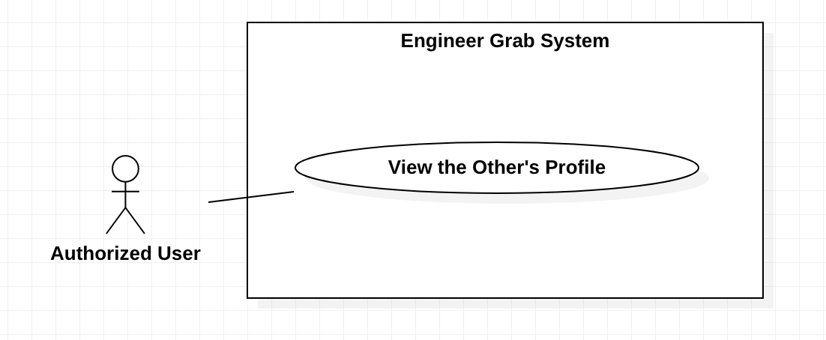

*Figure 12 - <Authorized User> View the Other’s Profile*

**Use Case Specifications**

|  |  |  |  |
| --- | --- | --- | --- |
| **USE CASE – Engineer Grab System** | | | |
| **Use Case No.** | EGS-09 | **Use Case Version** | 1.0 |
| **Use Case Name** | View the Other’s Profile | | |
| **Author** | HuyTQ | | |
| **Date** | 05/03/2020 | **Priority** | Normal |
| **Actor:**  - Authorized user.  **Summary:**  - This use case allows the authorized user to view the other’s profile.  **Goal:**  - Authorized user can view the other’s profile.  **Triggers:**  - Authorized user clicks on the other’s profile link.  **Preconditions:**  - Authorized user must login to the system.  **Postconditions:**  - **Success**: System shows the other’s profile details.  - **Fail**: System shows the error message.  **Main Success Scenarios:**   |  |  |  | | --- | --- | --- | | **Step** | **Actor Action** | **System Response** | | 1 | Authorized user clicks on the other’s profile link. | System shows information:  + Full name  + Images  + Sex  + Avatar  + District  + City  + Role  [Exception 1] |   **Alternative Scenarios:** N/A  **Exceptions:**   |  |  |  | | --- | --- | --- | | **No** | **Actor Action** | **System Response** | | 1 | The user is not available. | System shows the message: “The user is not available”. | | 2 | Internet problem. | System shows the message "System is busy" when the internet is lost. |   **Relationships:** N/A.  **Business Rules:**  - The profiles that have “active” status show for the customer and engineer.  - The profiles that have “new”, “active” and “deleted” status show for the admin.  - For the admin, the profile shows more details that include:  + User ID  + Status  + Address  + Phone  + Identify card  - If role is engineer, the profile shows more details that include:  + Career  + Curriculum Vitae  + Experience year | | | |

*Table 10 - <Authorized User> View the Other’s Profile*

#### 2.2.6 <Authorized User> View the Available Request

**Use Case Diagram**

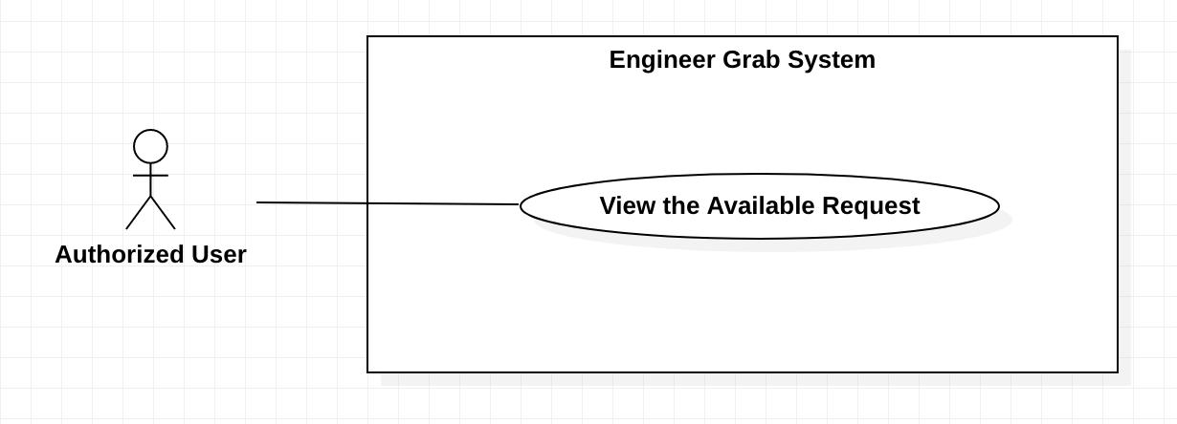

*Figure 13 - <Authorized User> View the Available Request*

**Use Case Specifications**

|  |  |  |  |
| --- | --- | --- | --- |
| **USE CASE – Engineer Grab System** | | | |
| **Use Case No.** | EGS-10 | **Use Case Version** | 1.0 |
| **Use Case Name** | View the Available Request | | |
| **Author** | HuuDN | | |
| **Date** | 30/03/2020 | **Priority** | Normal |
| **Actor:**  - Authorized User.  **Summary:**  - This use case allows the authorized user to view the available request.  **Goal:**  - Authorized user can view the available request.  **Triggers:**  - Authorized user clicks on the available request link.  **Preconditions:**  - Authorized user must login to the system.  **Postconditions:**  - **Success**: Authorized user views the available request details successfully.  - **Fail**: System shows the error message.  **Main Success Scenarios:**   |  |  |  | | --- | --- | --- | | **Step** | **Actor Action** | **System Response** | | 1 | Authorized user clicks on the available request link. | System shows the available request details that includes:  + Title  + Content  + Image  + Service  + District  + City  + Requested time  + Promotion  + Created Time  [Exception 1] |   **Alternative Scenarios:** N/A  **Exceptions:**   |  |  |  | | --- | --- | --- | | **No** | **Actor Action** | **System Response** | | 1 | The request is not available. | System shows the message: “This request is not available”. | | 2 | Internet problem. | System shows the message: "System is busy" when the internet is lost. |   **Relationships:** N/A  **Business Rules:**  - The requests that have “Active” status show for the customer and engineer.  - The requests that have “New”, “Active”, “Deleted” and “Canceled” status show for the admin.  - For the admin, the requests shows more the details that include:  + Request id  + Requestor’s name  + Requestor’s phone  + Requestor’s address  + Poster  + Status  - The requests must be sorted by descending created time.  - The requests must be paging. | | | |

*Table 11 - <Authorized User> View the Available Request*

#### 2.2.7 <Authorized User> Logout

**Use Case Diagram**

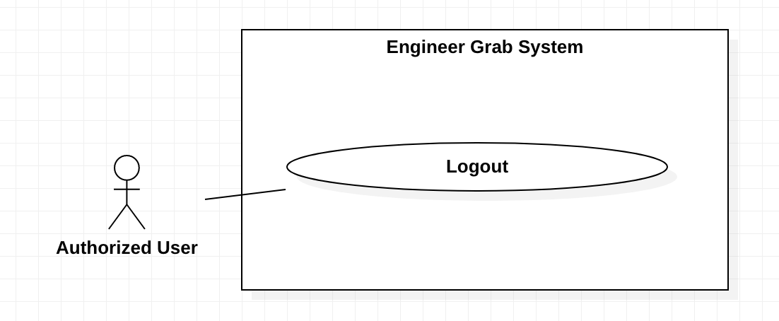

*Figure 14 - <Authorized User> Logout*

**Use Case Specifications**

|  |  |  |  |
| --- | --- | --- | --- |
| **USE CASE – Engineer Grab System** | | | |
| **Use Case No.** | EGS-11 | **Use Case Version** | 1.0 |
| **Use Case Name** | Logout | | |
| **Author** | HuyTQ | | |
| **Date** | 12/03/2020 | **Priority** | Normal |
| **Actor:**  - Authorized User.  **Summary:**  - This use case allows the authorized user to logout the system.  **Goal:**  - Authorized user can logout from the system.  **Triggers:**  - Authorized user clicks on the “Logout” button.  **Preconditions:**  - Authorized user must login to the system.  **Postconditions:**  - **Success**: Authorized user logout from the system successfully.  - **Fail**: System shows the error message.  **Main Success Scenarios:**   |  |  |  | | --- | --- | --- | | **Step** | **Actor Action** | **System Response** | | 1 | Authorized user clicks on the “Logout” button on navigation menu. | System shows Logout dialog with message:” Do you want to logout? ”. | | 2 | Authorized user clicks on the “Yes” button. | Authorized user logout the system. |   **Alternative Scenarios:** N/A  **Exceptions:**   |  |  |  | | --- | --- | --- | | **No** | **Actor Action** | **System Response** | | 1 | Authorized user clicks on the “No” button. | System closed Logout form. | | 2 | Internet problem. | System shows message: "The system is busy" when the internet is lost. |   **Relationships:** N/A.  **Business Rules:**  - After authorized user logout from the system, system redirects to the home page. | | | |

*Table 12 - <Authorized User> Logout*

### 2.3 <Customer> Overview Use Case

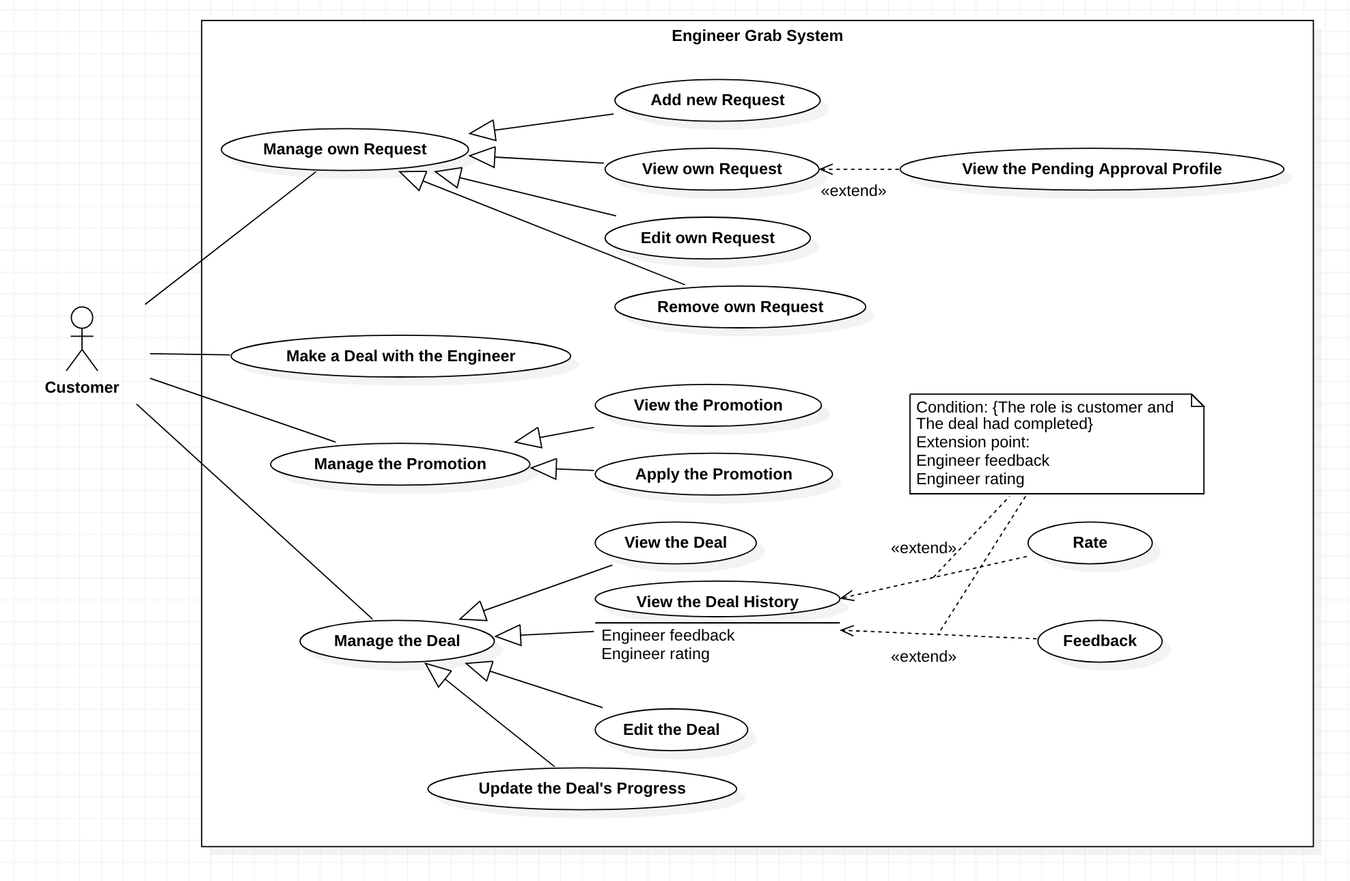

*Figure 15 - < Customer> Overview Use Case*

#### 2.3.1 <Customer> Add new Request

**Use Case Diagram**

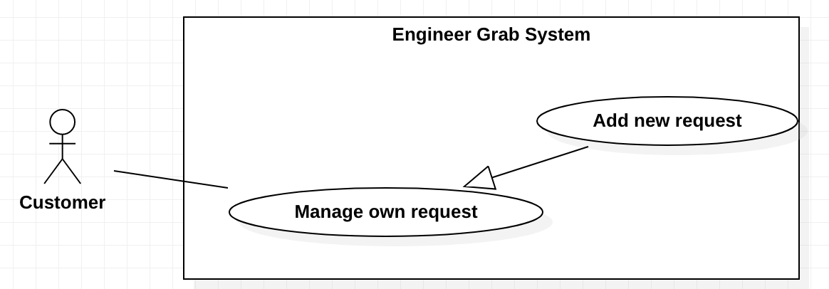

*Figure 16 - <Customer> Add new Request*

**Use Case Specifications**

|  |  |  |  |
| --- | --- | --- | --- |
| **USE CASE - Engineer Grab System** | | | |
| **Use Case No.** | EGS-12 | **Use Case Version** | 1.0 |
| **Use Case Name** | Add a new request | | |
| **Author** | TruongTN | | |
| **Date** | 23/02/2020 | **Priority** | High |
| **Actor:**  - Customer  **Summary:**  - This use case allows the customer to create new request.  **Goal:**  - Customer can create new request.  **Triggers:**  - Customer clicks on the “Create new request” button.  **Preconditions:**  - Customer must login to the system.  **Postconditions:**  - **Success**: Customer creates new request successfully.  - **Fail**: System shows the error message.  **Main Success Scenario:**   |  |  |  | | --- | --- | --- | | **Step** | **Actor Action** | **System Response** | | 1 | Customer clicks on the “Create new request” button. | System shows the form that includes:  - Title: input.  - Content: input.  - Images: image.  - Requestor’s name: input.  - Requestor’s address: input.  - Requestor’s phone: input.  - Requested time: calendar.  - Service name: combobox.  - City: combobox  - District: combobox. | | 2. | Customer inputs the fields. |  | | 3 | Customer clicks on the “Finish” button. | System shows the message : “ Your request has been sent to admin and awaits approval.”  [Exception 1] |   **Alternative Scenarios:** N/A  **Exception**s**:**   |  |  |  | | --- | --- | --- | | **No** | **Actor Action** | **System Response** | | 1 | Customer inputs or selects invalid fields. | System shows message with the corresponding fields:  - Title: must be inputted from 6 to 200 characters.  - Content: must be inputted.  - Image: must be choosen.  - Requestor’s name: must be inputted from 6 to 50 charactes.  - Requestor’s address: must be inputted.  - Requestor’s phone: must be inputted from 10 to 12 numbers.  - Requested time: must be inputted.  - Service name: must be chosen.  - City: must be choosen  - District: must be choosen | | 2 | Internet problem | System shows the message: "System is busy" when the internet is lost. |   **Relationships:** N/A  **Business Rules:**  - Customer can apply the promotion in the request.  - Customer can view the details of the request before clicking the “Finish” button.  - The new request has “New” status. After the request is accepted, the status is changed to “Active”.  - When customer clicks the “Finish” button:  + System shows the message “Create request successfully”.  + System redirects to the view request screen. | | | |

*Table 13 - <Customer > Add new Request*

#### 2.3.2 <Customer> View own Request

**Use Case Diagram**

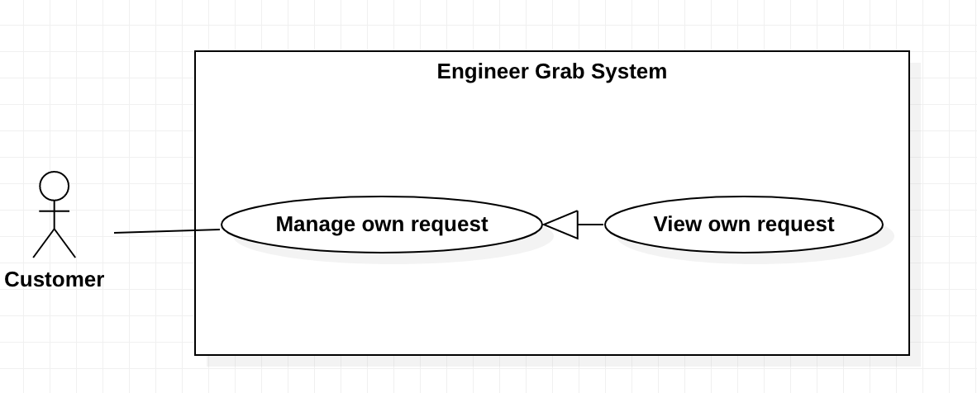

*Figure 17 - <Customer> View own Request*

**Use Case Specifications**

|  |  |  |  |
| --- | --- | --- | --- |
| **USE CASE - Engineer Grab System** | | | |
| **Use Case No.** | EGS-13 | **Use Case Version** | 1.0 |
| **Use Case Name** | View own request | | |
| **Author** | TruongTN | | |
| **Date** | 23/02/2020 | **Priority** | Normal |
| **Actor:**  - Customer  **Summary:**  - This use case allows cutstomer to view own request.  **Goal:**  - Customer can view own request informations.  **Triggers:**  - Customer click on own request link.  **Preconditions:**  - Customer must login to the system.  **Postconditions:**  - **Success**: Customer can view own request details successfully.  - **Fail**: System shows the error message.  **Main Success Scenario:**   |  |  |  | | --- | --- | --- | | **Step** | **Actor Action** | **System Response** | | 1 | Customer clicks “My request” on navigation menu. | System redirects to view own request screen with list of requests.  [Exception 1] | | 2 | Customer clicks on a request link. | System redirects to view own request details screen. Customer can view information of the request.  [Exception 2] |   **Alternative Scenarios:** N/A  **Exceptions:**   |  |  |  | | --- | --- | --- | | **No** | **Actor Action** | **System Response** | | 1 | Customer does not have requests. | System shows the message: “You have no the request.” | | 2 | The request is not available. | System shows the message: “The request is not available”. | | 3 | Internet problem. | System shows the message: "System is busy" when the internet is lost. |   **Relationships:** N/A  **Business Rules:**  - System shows the list of requests base on customer’s id.  - Customer can view the requests that have “New” , “Active”, “Canceled” status.  - The list of requests must be paging.  - The list of requests must be sorted by descending created time.  - The view own request screen must have:   1. Title. 2. Content. 3. Status. 4. Created time 5. Requestor’s phone. 6. Requestor’s name. 7. Requestor’s address. 8. Requested time. 9. Service name. 10. Promotion details. | | | |

*Table 14 - <Customer > View own Request*

#### 2.3.3 <Customer> View the Pending Approval Profile

**Use Case Diagram**

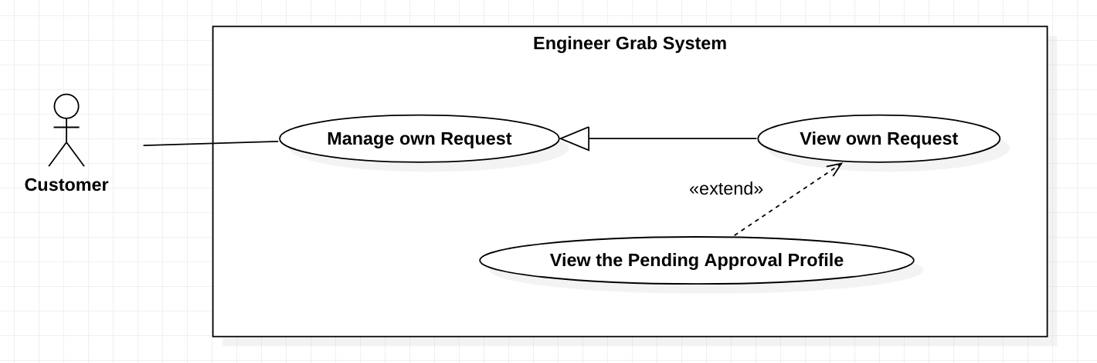

*Figure 18 - <Customer> View the Pending Approval Profile*

**Use Case Specifications**

|  |  |  |  |
| --- | --- | --- | --- |
| **USE CASE – Engineer Grab System** | | | |
| **Use Case No.** | EGS-14 | **Use Case Version** | 1.0 |
| **Use Case Name** | View the Pending Approval Profiles | | |
| **Author** | HuuDN | | |
| **Date** | 30/03/2020 | **Priority** | Normal |
| **Actor:**  - Customer.  **Summary:**  - This use case allows the customer to view the pending approval profiles.  **Goal:**  - Customer can view the pending approval profiles of the engineers that want to repair the customer’s problem.  **Triggers:**  - Customer clicks on the own request link.  **Preconditions:**  - Customer must login to the system.  - Customer has approved request.  **Postconditions:**  - **Success**: Customer views the pending approval profiles of engineer successfully.  - **Fail**: System shows the error message.  **Main Success Scenarios:**   |  |  |  | | --- | --- | --- | | **Step** | **Actor Action** | **System Response** | | 1 | Customer clicks on the own request link. | System shows the list of profiles of the engineers that want to repair it with information includes:  + Engineer’s name  + Engineer’s avatar  + Average rate  + Career and experience year  + Applied time  [Exception 1] |   **Alternative Scenarios:** N/A  **Exceptions:**   |  |  |  | | --- | --- | --- | | **No** | **Actor Action** | **System Response** | | 1 | List of the profiles of engineers is empty. | System shows the message: “There is no submitted profile.”. | | 2 | Internet problem. | System shows the message: "System is busy" when the internet is lost. |   **Relationships:** This use case extends from the “View own Request” use case.  **Business Rules:**  - All engineers who have a deal before or after 1 hour this requested time are canceled.  - The canceled profiles will not be shown.  - The profiles of the engineers must be sorted by ascending applied time.  - The profiles of the engineers must be paging. | | | |

*Table 15 - <Customer > View the Pending Approval Profile*

#### 2.3.4 <Customer> Edit own Request

**Use Case Diagram**

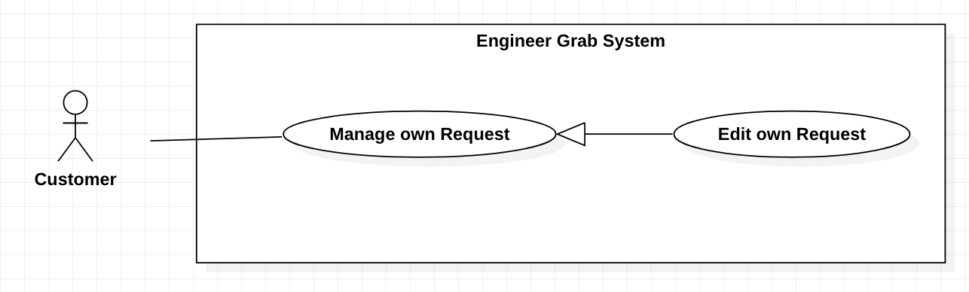

*Figure 19 - <Customer> Edit own Request*

**Use Case Specifications**

|  |  |  |  |
| --- | --- | --- | --- |
| **USE CASE – Engineer Grab System** | | | |
| **Use Case No.** | EGS-15 | **Use Case Version** | 1.0 |
| **Use Case Name** | Edit own Request | | |
| **Author** | HuyTQ | | |
| **Date** | 28/03/2020 | **Priority** | Normal |
| **Actor:**  - Customer.  **Summary:**  - This use case allows the customer to edit own request.  **Goal:**  - Customer can edit own request.  **Triggers:**  - Customer clicks on the “Edit” button.  **Preconditions:**  - Customer must log in the system.  - Customer is on the request details page.  **Postconditions:**  - **Success**: Customer edits own request successfully.  - **Fail**: System shows the error message.  **Main Success Scenarios:**   |  |  |  | | --- | --- | --- | | **Step** | **Actor Action** | **System Response** | | 1 | Customer clicks on the “Edit” button. | System shows the form that includes:  + Title: input  + Content: input  + Images: image  + Requestor’s name: input  + Requestor’s phone: input  + Requestor’s address: input  + Requested time: calendar  + City: combobox  + District: combobox  + Service: combobox  + Promotion: input  [Exception 1] | | 2 | Customer inputs or selects the fields. |  | | 3 | Customer clicks on the “Save” button. | System shows the message:” Edit successfully”.  [Exception 1, 2, 3, 4, 5, 6, 7, 8, 9, 10] |   **Alternative Scenarios:** N/A  **Exceptions:**   |  |  |  | | --- | --- | --- | | **No** | **Actor Action** | **System Response** | | 1 | The request is not available. | System shows the message: “The request is not available”. | | 2 | The title includes 50 – 200 characters. | System shows the message: “The title includes 50 – 200 characters.” | | 3 | The content is blank. | System shows the message: “The content is required”. | | 4 | The images are empty. | System shows the message: “The images are required”. | | 5 | The requestor’s name includes 6 -50 characters. | System shows the message: “The requestor’s name includes 6 - 50 characters.” | | 6 | The requestor’s phone includes 10 – 12 digits. | System shows the message: “The requestor’s phone includes 10 – 12 digits.” | | 7 | The requestor’s address is blank. | System shows the message: “The requestor’s address is required”. | | 8 | The requested time is not greater than current time. | System shows the message: “The requested time must be greater than current time.”. | | 9 | The promotion is not available. | System shows the message: “The promotion is not available”. | | 13 | Internet problem. | System shows message "System is busy" when the internet is lost. |   **Relationships:** N/A  **Business Rules:**  - Editing information must be confirmed by admin.  - After the customer had edited, system redirects to the request page. | | | |

*Table 16 - <Customer > Edit own Request*

#### 2.3.5 <Customer> Remove own Request

**Use Case Diagram**

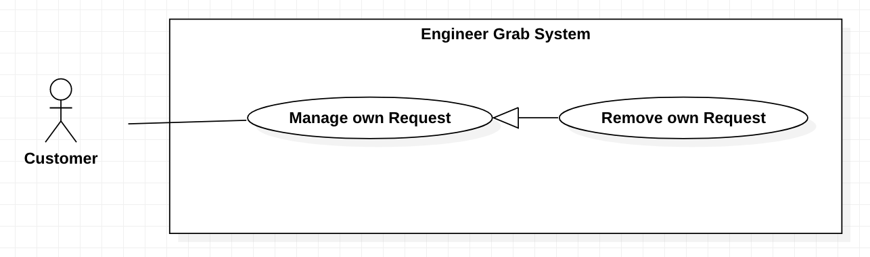

*Figure 20 - <Customer> Remove own Request*

**Use Case Specifications**

|  |  |  |  |
| --- | --- | --- | --- |
| **USE CASE – Engineer Grab System** | | | |
| **Use Case No.** | EGS-16 | **Use Case Version** | 1.0 |
| **Use Case Name** | Remove own Request | | |
| **Author** | HuyTQ | | |
| **Date** | 30/03/2020 | **Priority** | Normal |
| **Actor:**  - Customer.  **Summary:**  - This use case allows the customer to remove the own request.  **Goal:**  - Customer can remove the own request.  **Triggers:**  - Customer clicks on the “Remove” button.  **Preconditions:**  - Customer must login to the system.  - Customer is on the page of the request's details that has "active" or "new" status.  **Postconditions:**  - **Success**: Customer removes the own request successfully.  - **Fail**: System shows the error message.  **Main Success Scenarios:**   |  |  |  | | --- | --- | --- | | **Step** | **Actor Action** | **System Response** | | 1 | Admin clicks on the “Remove” button. | System ask user to confirm the action | | 2 | Admin chooses to confirm the action. | System show message that service is deleted. |   **Alternative Scenarios:** N/A  **Exceptions:**   |  |  |  | | --- | --- | --- | | **No** | **Actor Action** | **System Response** | | 1 | Internet problem. | System shows the message "The system is busy" when the internet is lost. |   **Relationships:N/A**  **Business Rules:**  - System will change status of the request to “Deleted”.  - After removing, system redirects to the request page. | | | |

*Table 17 - <Customer > Remove own Request*

#### 2.3.6 <Customer> View the Promotion

**Use Case Diagram**

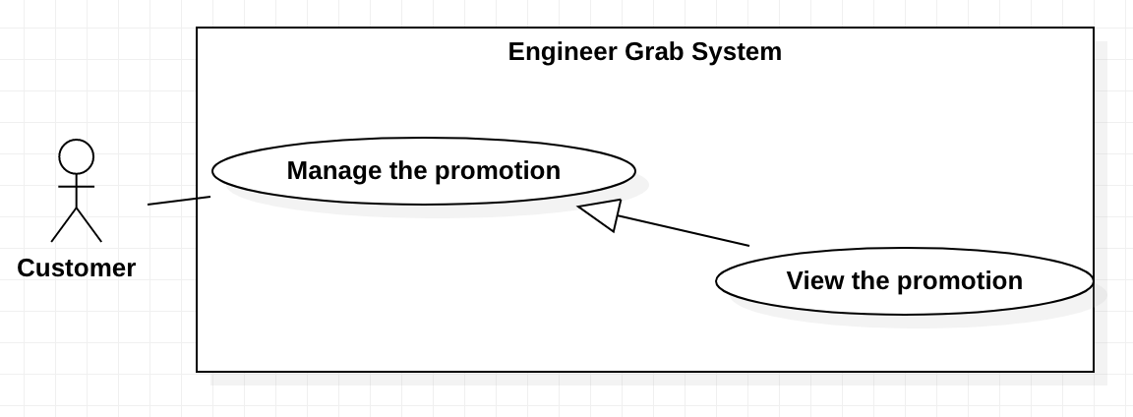

*Figure 21 - <Customer> View the Promotion*

**Use Case Specifications**

|  |  |  |  |
| --- | --- | --- | --- |
| **USE CASE - Engineer Grab System** | | | |
| **Use Case No.** | EGS-17 | **Use Case Version** | 1.0 |
| **Use Case Name** | View the promotion | | |
| **Author** | TruongTN | | |
| **Date** | 23/02/2020 | **Priority** | Normal |
| **Actor:**  **-** Customer  **Summary:**  - This use case allows the customer to view the promotion.  **Goal:**  - Customer can view the promotion.  **Triggers:**  - Customer clicks on the promotion link.  **Preconditions:**  - Customer must login to the system.  **Postconditions:**  - **Success**: System shows the promotion details.  - **Fail**: System shows the error message.  **Main Success Scenario:**   |  |  |  | | --- | --- | --- | | **Step** | **Actor Action** | **System Response** | | 1 | Customer clicks on the “My promotion” button on navigation menu. | System redirects to view the promotion screen with list of the promotions.  [Exception 1] | | 2 | Customer clicks on a promotion. | System redirects to view promtion details screen. Customer can view information of the promotion.  [Exception 2] |   **Alternative Scenarios:** N/A  **Exceptions:**   |  |  |  | | --- | --- | --- | | **No** | **Actor Action** | **System Response** | | 1 | Customer does not have a promotion. | System shows the message: “You have no the promotion.” | | 2 | The promotion is not available. | System shows the message: “The promotion is not available .”. | | 2 | Internet problem. | System shows the message: "System is busy" when the internet is lost. |   **Relationships:** N/A  **Business Rules:**  - The promotions must be paging.  - The promotions must be sorted by descending ended time.  - The promotion details screen must include:   1. Name of the promotion 2. Amount discount 3. Percent discount 4. Ended time 5. Status 6. Applied time | | | |

*Table 18 - <Customer > View the Promotion*

#### 2.3.7 <Customer> Apply the Promotion

**Use Case Diagram**

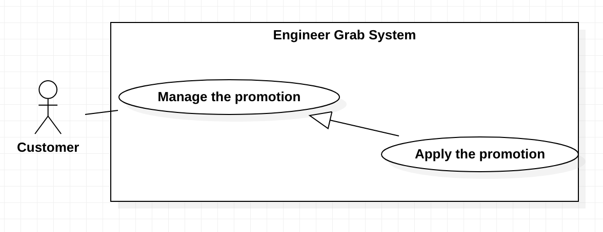

*Figure 22 - <Customer> Apply the Promotion*

**Use Case Specifications**

|  |  |  |  |
| --- | --- | --- | --- |
| **USE CASE - Engineer Grab System** | | | |
| **Use Case No.** | EGS-18 | **Use Case Version** | 1.0 |
| **Use Case Name** | Apply the promotion | | |
| **Author** | TruongTN | | |
| **Date** | 23/03/2020 | **Priority** | High |
| **Actor:**  **-** Customer  **Summary:**  **-** This use case allows the customer to apply the promotion.  **Goal:**  **-** Customer can apply the promotion.  **Triggers:**  **-** Customer clicks on the ”Apply the promotion” button.  **Preconditions:**  - Customer must login to the system.  - Customer is on the request details page.  **Post conditions:**  - **Success**: Customer can apply the promotion successfully.  - **Fail**: System shows the error message.  **Main Success Scenario:**   |  |  |  | | --- | --- | --- | | **Step** | **Actor Action** | **System Response** | | 1 | Customer inputs the promotion’s name. |  | | 2 | Customer clicks on the “Apply the promotion” button. | System shows the message that the promotion is applied for this request.  [Exception 1, 2, 3] |   **Alternative Scenarios:** N/A  **Exceptions:**   |  |  |  | | --- | --- | --- | | **No** | **Actor Action** | **System Response** | | 1 | The promotion’s name is blank. | System shows the message: “The promotion’s name is required.”. | | 2 | The promotion is not available. | System shows the message: “The promotion is not available.”. | | 3 | The promotion is used. | System shows the message: “ The promotion is used.”. | | 4 | Internet problem. | System shows the message: "System is busy" when the internet is lost. |   **Relationships:** N/A  **Business Rules:**  - If the promotions have “Deleted” status or out of date, they can not apply for the request.  - After the promotion is used, the promotion’s status is changed to “Used” and system stores the applied time. | | | |

*Table 19 - <Customer > Apply the Promotion*

#### 2.3.8 <Customer> Make a Deal with the Engineer

**Use Case Diagram**

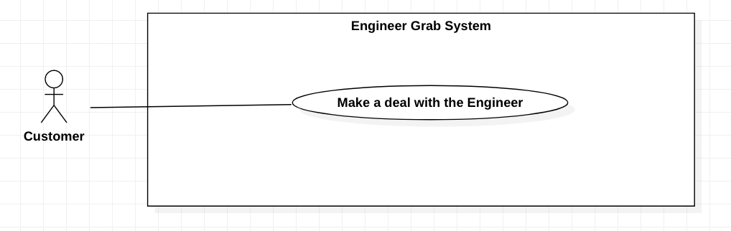

*Figure 23 - <Customer> Make a Deal with the Engineer*

**Use Case Specifications**

|  |  |  |  |
| --- | --- | --- | --- |
| **USE CASE – Engineer Grab System** | | | |
| **Use Case No.** | EGS-19 | **Use Case Version** | 1.0 |
| **Use Case Name** | Make a deal with the engineer | | |
| **Author** | HuuDN | | |
| **Date** | 30/03/2020 | **Priority** | High |
| **Actor:**  - Customer.  **Summary:**  - This use case allows the customer to make a deal with the Engineer.  **Goal:**  - Customer makes a deal.  **Triggers:**  - Customer clicks on the “Make a deal” button.  **Preconditions:**  - Customer must login to the system.  - Customer must post the request for what they have a problem that needs fixing.  - Customer’s request must be approved by the Admin and posted on the system.  - Customer's request has submitted the profile of the engineers who want to repair the customer’s problem.  - Customer is on the request details page.  **Postconditions:**  - **Success**: Customer makes a deal successfully.  - **Fail**: System shows the error message.  **Main Success Scenarios:**   |  |  |  | | --- | --- | --- | | **Step** | **Actor Action** | **System Response** | | 1 | Customer clicks on the “Make a deal” button with the appropriate engineer profile. | System shows the message: “Make a deal successfully.”.  [Exception 1] |   **Alternative Scenarios:** N/A  **Exceptions:**   |  |  |  | | --- | --- | --- | | **No** | **Actor Action** | **System Response** | | 1 | Engineer is not available. | System shows the message: “This engineer is not available.” | | 2 | Internet problem. | System shows the message: "The system is busy" when the internet is lost. |   **Relationships:** N/A  **Business Rules:**  - The submitted profiles of the engineers who have an deal 1 hour before or after the requested time of this request will be automatically canceled.  - The request’s status must be changed to "In repair".  - The status submitted profiles of another engineers must be changed to "Canceled".  - System must notify the engineer that they have a deal with the customer.  - System redirects to the home page. | | | |

*Table 20 - <Customer > Make a Deal with the Engineer*

#### 2.3.9 <Customer> View The Deal

**Use Case Diagram**

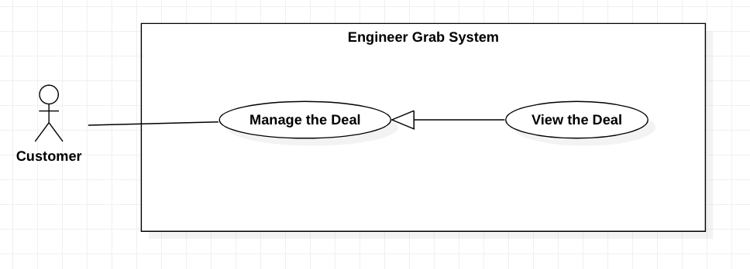

*Figure 24 - <Customer> View the Deal*

**Use Case Specifications**

|  |  |  |  |
| --- | --- | --- | --- |
| **USE CASE – Engineer Grab System** | | | |
| **Use Case No.** | EGS-20 | **Use Case Version** | 1.0 |
| **Use Case Name** | View the Deal | | |
| **Author** | HuuDN | | |
| **Date** | 30/03/2020 | **Priority** | Normal |
| **Actor:**  - Customer.  **Summary:**  - This use case allows the customer to view the deal details.  **Goal:**  - Customer can view the deal details.  **Triggers:**  - Customer clicks on the “Manage Deal” button on navigation menu.  **Preconditions:**  - Customer must login to the system.  **Postconditions:**  - **Success**: Customer views the deal details successfully.  - **Fail**: System shows the error message.  **Main Success Scenarios:**   |  |  |  | | --- | --- | --- | | **Step** | **Actor Action** | **System Response** | | 1 | Customer clicks on the “Manage Deal” button on navigation menu. | System shows the list of the deals details that have “pending repair” or “in repair” progress.  [Exception 1] | | 2 | Customer clicks on the deal link. | System shows the deal details that includes:  + Title.  + Content.  + Image. + Requestor’s name.  + Requestor’s phone.  + Requestor’s address.  + City.  + District.  + Requested time  + Poster  + Deal’s progress.  + Service.  + Promotion.  + Accepted deal time.  [Exception 2] |   **Alternative Scenarios:** N/A  **Exceptions:**   |  |  |  | | --- | --- | --- | | **No** | **Actor Action** | **System Response** | | 1 | List of the deals details that have “pending repair” or “in repair” progress is empty. | System shows the message: “You do not have a deal.” | | 2 | The deal is not available. | System shows the message: “This deal is not available”. | | 3 | Internet problem. | System shows the message: "System is busy" when the internet is lost. |   **Relationships:** N/A  **Business Rules:**  - The deals must be sorted by ascending requested time.  - The deals must be paging. | | | |

*Table 21 - <Customer > View the Deal*

#### 2.3.10 <Customer> Edit the Deal

**Use Case Diagram**

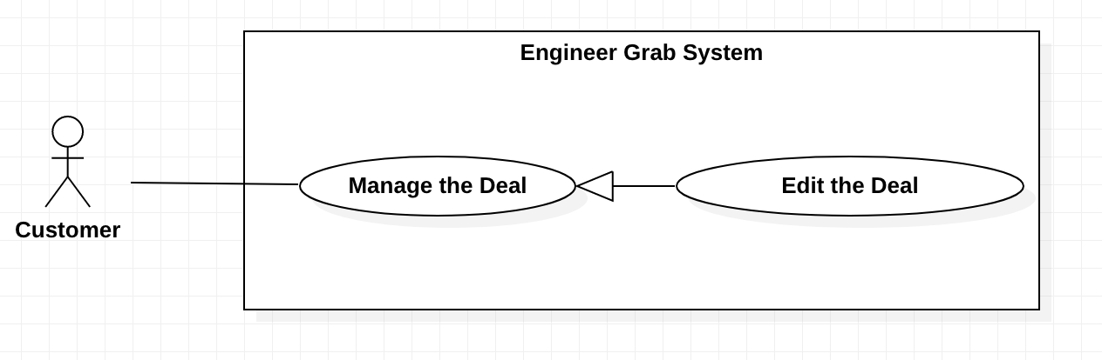

*Figure 25 - <Customer> Edit the Deal*

**Use Case Specifications**

|  |  |  |  |
| --- | --- | --- | --- |
| **USE CASE – Engineer Grab System** | | | |
| **Use Case No.** | EGS-21 | **Use Case Version** | 1.0 |
| **Use Case Name** | Edit the Deal | | |
| **Author** | HuuDN | | |
| **Date** | 30/03/2020 | **Priority** | Normal |
| **Actor:**  - Customer.  **Summary:**  - This use case allows the customer to edit the deal details.  **Goal:**  - Customer can edit the deal details.  **Triggers:**  - Customer clicks on the “Edit” button below the deal details.  **Preconditions:**  - Customer must login to the system.  - Customer must have a deal that has “Pending repair” progress.  - Customer is on the deal details page.  **Postconditions:**  - **Success**: Customer edits the deal details successfully.  - **Fail**: System shows the error message.  **Main Success Scenarios:**   |  |  |  | | --- | --- | --- | | **Step** | **Actor Action** | **System Response** | | 1 | Customer clicks on the “Edit” button below the deal details. | System shows the form that includes:  + Requestor’s name: input  + Requestor’s phone: input  + Requestor’s address: input  + City: combobox  + District: combobox  + Requested time: calendar  + Promotion: input  [Exception 1] | | 2 | Customer inputs or selecteds the fields. |  | | 3 | Customer clicks on the “Submit” button. | System shows the successful message: “Edit successful”.  [Exception 1, 2, 3, 4, 5, 6] |   **Alternative Scenarios:** N/A  **Exceptions:**   |  |  |  | | --- | --- | --- | | **No** | **Actor Action** | **System Response** | | 1 | The deal is not available. | System shows the message: “This deal is not available”. | | 2 | The requestor’s name includes 6 – 50 characters. | System shows the message: “The requestor’s name includes 6 – 50 characters.” | | 3 | The requestor’s phone includes 10 – 12 digits. | System shows the message: “The requestor’s phone includes 10 – 12 digits.” | | 4 | The requestor’s address is blank. | Systems shows the message: “The requestor’s address is required.”. | | 5 | The requested time is not greater than current time. | System shows the message: “The requested time must be greater than current time.”. | | 6 | The promotion is not available. | System shows the message: “The promotion is not available.”. | | 7 | Internet problem. | System shows the message: "The system is busy" when the internet is lost. |   **Relationships:** N/A  **Business Rules:**  - A promotion is only applied to a request.  - After the deal is edited, system will notify to the engineer.  - System redirects to the deal details page. | | | |

*Table 22 - <Customer > Edit the Deal*

#### 2.3.11 <Customer> Update the Deal’s Progress

**Use Case Diagram**

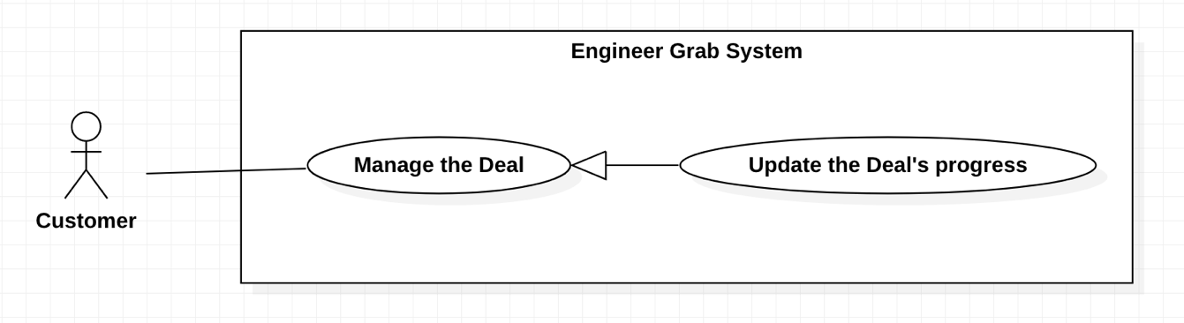

*Figure 25 - <Customer> Update the Deal’s progress*

**Use Case Specifications**

|  |  |  |  |
| --- | --- | --- | --- |
| **USE CASE – Engineer Grab System** | | | |
| **Use Case No.** | EGS-22 | **Use Case Version** | 1.0 |
| **Use Case Name** | Update the Deal’s progress | | |
| **Author** | HuuDN | | |
| **Date** | 30/03/2020 | **Priority** | High |
| **Actor:**  - Customer.  **Summary:**  - This use case allows the customer to update the deal’s progress.  **Goal:**  - Customer can update the deal’s progress.  **Triggers:**  - Customer clicks on the “Cancel” button below the detais of a deal that has “pending repair” progress.  - Customer clicks on the “Complete” button below the details of a deal that has “in repair” progress.  **Preconditions:**  - Customer must login to the system.  - Customer must have a deal that has “pending repair” or “in repair” progress.  - Customer is on the deal details page.  **Postconditions:**  - **Success**: Customer updates the deal’s progress successfully.  - **Fail**: System shows the error message.  **Main Success Scenarios:**   |  |  |  | | --- | --- | --- | | **Step** | **Actor Action** | **System Response** | | 1 | Customer clicks on the “Cancel” button below the deal details.  [Alternative 1] | System asks the customer to confirm the action.  [Exception 1] | | 2 | Customer chooses to confirm the action. | System shows the successful message. |   **Alternative Scenarios:**   |  |  |  | | --- | --- | --- | | **Step** | **Actor Action** | **System Response** | | 1 | Customer clicks on the “Complete” button below the deal details. | System asks the customer to confirm the action. |   **Exceptions:**   |  |  |  | | --- | --- | --- | | **No** | **Actor Action** | **System Response** | | 1 | The deal is not available. | System shows the message: “This deal is not available”. | | 2 | Internet problem. | System shows the message: "System is busy" when the internet is lost. |   **Relationships:** N/A  **Business Rules:**  - Customer can only cancel the deals that have “Pending repair” progress.  - After the deal is canceled, the request’s status of this deal is changed to “Acitve”.  - After the deal is canceled, the status of this deal is changed to “Canceled” and system will notify the engineer.  - Customer can only complete the deals that have “In repair” progress.  - After the deal is completed, the request’s status of this deal is changed to “Completed”.  - After the deal is completed, the status of this deal is changed to “Completed”.  - System redirects to the deal details page. | | | |

*Table 23 - <Customer > Update the Deal’s progress*

#### 2.3.12 <Customer> View the Deal History

**Use Case Diagram**

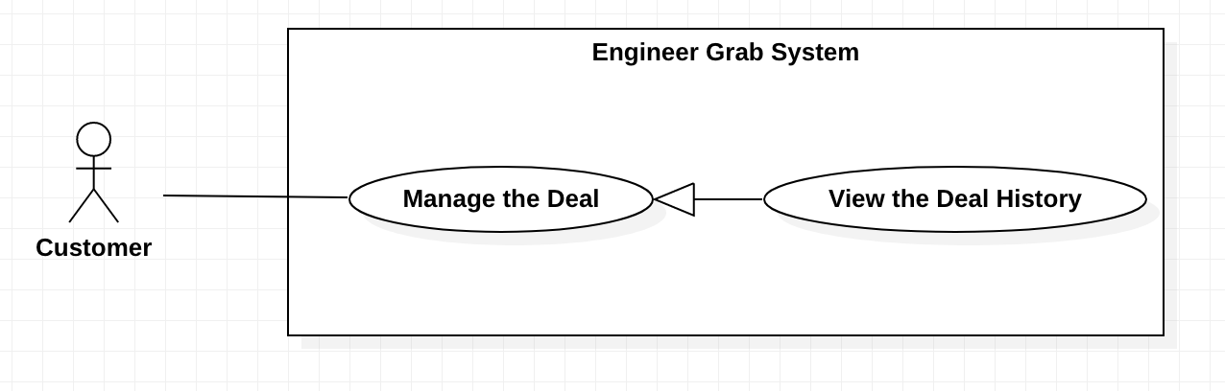

*Figure 26 - <Customer> View the Deal History*

**Use Case Specifications**

|  |  |  |  |
| --- | --- | --- | --- |
| **USE CASE – Engineer Grab System** | | | |
| **Use Case No.** | EGS-23 | **Use Case Version** | 1.0 |
| **Use Case Name** | View the Deal History | | |
| **Author** | HuuDN | | |
| **Date** | 30/03/2020 | **Priority** | Normal |
| **Actor:**  - Customer.  **Summary:**  - This use case allows the customer to view the deal history.  **Goal:**  - Customer can view the deal history.  **Triggers:**  - Customer clicks on the “Deal History” button on navigation menu.  **Preconditions:**  - Customer must login to the system.  **Postconditions:**  - **Success**: Customer view the deal history details successfully.  - **Fail**: System shows the error message.  **Main Success Scenarios:**   |  |  |  | | --- | --- | --- | | **Step** | **Actor Action** | **System Response** | | 1 | Customer clicks on the “Deal History” button on navigation menu. | System shows the list of the deals details that have “completed” or “canceled” progress.  [Exception 1] | | 2 | Customer clicks on the completed deal link.  [Alternative 1] | System shows the deal details that includes:  + Title  + Content  + Image + Requestor’s name  + Requestor’s phone  + Requestor’s address  + City  + District  + Requested time  + Deal’s progress  + Service  + Promotion  + Engineer’s profile  + Accepted deal time  + Completed deal time  + Rating  + Feedback  [Exception 2] |   **Alternative Scenarios:**   |  |  |  | | --- | --- | --- | | **Step** | **Actor Action** | **System Response** | | 1 | Customer clicks on the canceled deal link. | System shows the deal details that includes:  + Title  + Content  + Image  + Deal’s progress  + Service  + Promotions  + Accepted deal time  + Canceled deal time  [Exception 2] |   **Exceptions:**   |  |  |  | | --- | --- | --- | | **No** | **Actor Action** | **System Response** | | 1 | List of the deals details that have “completed” or “canceled” progress is empty. | System shows the message: “You do not have a deal”. | | 2 | The deal is not available. | System shows the message: “This deal is not available”. | | 2 | Internet problem. | System shows the message: "The system is busy" when the internet is lost. |   **Relationships:** N/A  **Business Rules:**  - The deals must be sorted by descending completed and canceled time.  - The deals must be paging. | | | |

*Table 24 - <Customer > View the Deal History*

#### 2.3.13 <Customer> Feedback

**Use Case Diagram**

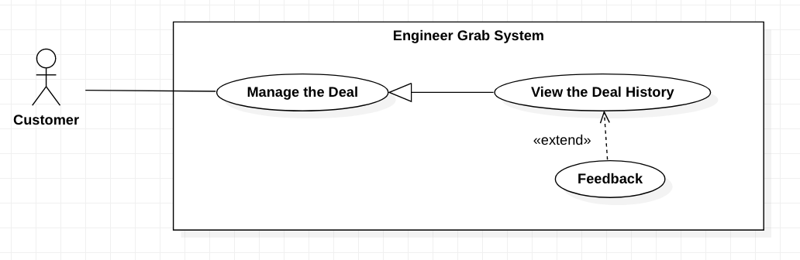

*Figure 27 - <Customer> Feedback*

**Use Case Specifications**

|  |  |  |  |
| --- | --- | --- | --- |
| **USE CASE – Engineer Grab System** | | | |
| **Use Case No.** | EGS-24 | **Use Case Version** | 1.0 |
| **Use Case Name** | Feedback | | |
| **Author** | HuuDN | | |
| **Date** | 30/03/2020 | **Priority** | High |
| **Actor:**  - Customer.  **Summary:**  - This use case allows the customer to feedback on the completed deal.  **Goal:**  - Customer feedbacks to the engineers.  **Triggers:**  - Customer clicks on the “Submit” button.  **Preconditions:**  - Customer must login to the system.  - The deal of the customer and the engineer must be completed.  - Customer is on the deal history page.  **Postconditions:**  - **Success**: Customer feedbacks to the engineers succesfully.  - **Fail**: System shows the error message.  **Main Success Scenarios:**   |  |  |  | | --- | --- | --- | | **Step** | **Actor Action** | **System Response** | | 1 | Customer clicks on the deal details link. | System shows the form that includes:  + Feedback the engineer: input  + Submit: button | | 2 | Customer inputs the feedback text. |  | | 3 | Customer clicks on the “Submit” button. | System shows the message: “Thanks for your feedback.”  [Exception 1] |   **Alternative Scenarios:** N/A  **Exceptions:**   |  |  |  | | --- | --- | --- | | **No** | **Actor Action** | **System Response** | | 1 | Feedback is blank. | System shows the message: “Please input your feedback before submitting”. | | 2 | Internet problem. | System shows the message: “System is busy" when the internet is lost. |   **Relationships:** This use case extends from the “View the Deal History” use case.  **Business Rules:**  - Only customer can feedback to the engineers.  - System redirects to the deal history page. | | | |

*Table 25 - <Customer > Feedback*

#### 2.3.14 <Customer> Rate

**Use Case Diagram**

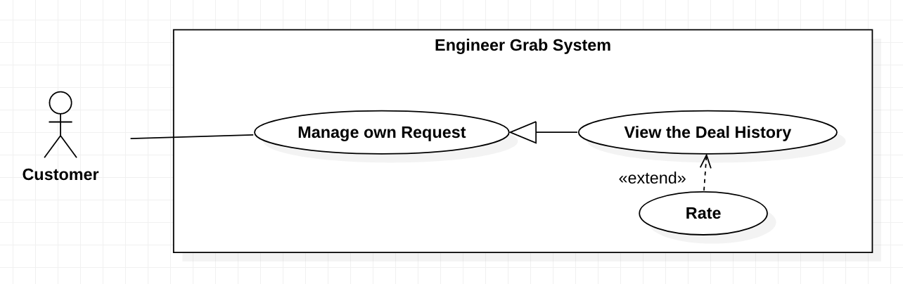

*Figure 28 - <Customer> Rate*

**Use Case Specifications**

|  |  |  |  |
| --- | --- | --- | --- |
| **USE CASE – Engineer Grab System** | | | |
| **Use Case No.** | EGS-25 | **Use Case Version** | 1.0 |
| **Use Case Name** | Rate | | |
| **Author** | HuuDN | | |
| **Date** | 30/03/2020 | **Priority** |  |
| **Actor:**  - Customer.  **Summary:**  - This use case allows the customer to rate on the completed deal.  **Goal:**  - Customer rates to the engineers.  **Triggers:**  - Customer clicks on the “Submit” button.  **Preconditions:**  - Customer must login to the system.  - The deal of the customer and the engineer must be completed.  - Customer is on the deal history page.  **Postconditions:**  - **Success**: Customer rates to the engineer successfully.  - **Fail**: System shows the error message.  **Main Success Scenarios:**   |  |  |  | | --- | --- | --- | | **Step** | **Actor Action** | **System Response** | | 1 | Customer clicks on the deal details link. | System shows the form that includes:  + Rating the engineer: point  + Submit: button | | 2 | Customer clicks the rating point. |  | | 3 | Customer clicks on the “Submit” button. | System shows the message: “Thanks for your rating.”  [Exception 1] |   **Alternative Scenarios:** N/A  **Exceptions:**   |  |  |  | | --- | --- | --- | | **No** | **Actor Action** | **System Response** | | 1 | Rating point is 0 point. | System shows the message: “Please rating before submitting”. | | 2 | Internet problem. | System shows the message: "The system is busy" when the internet is lost. |   **Relationships:** This use case extends from the “View the Deal History” use case.  **Business Rules:**  - Rating point is from 0.5 to 5 points.  - Only customer can rate to the engineers.  - System redirects to the deal history page. | | | |

*Table 26 - <Customer > Rate*

### 2.4 <Engineer> Overview Use Case

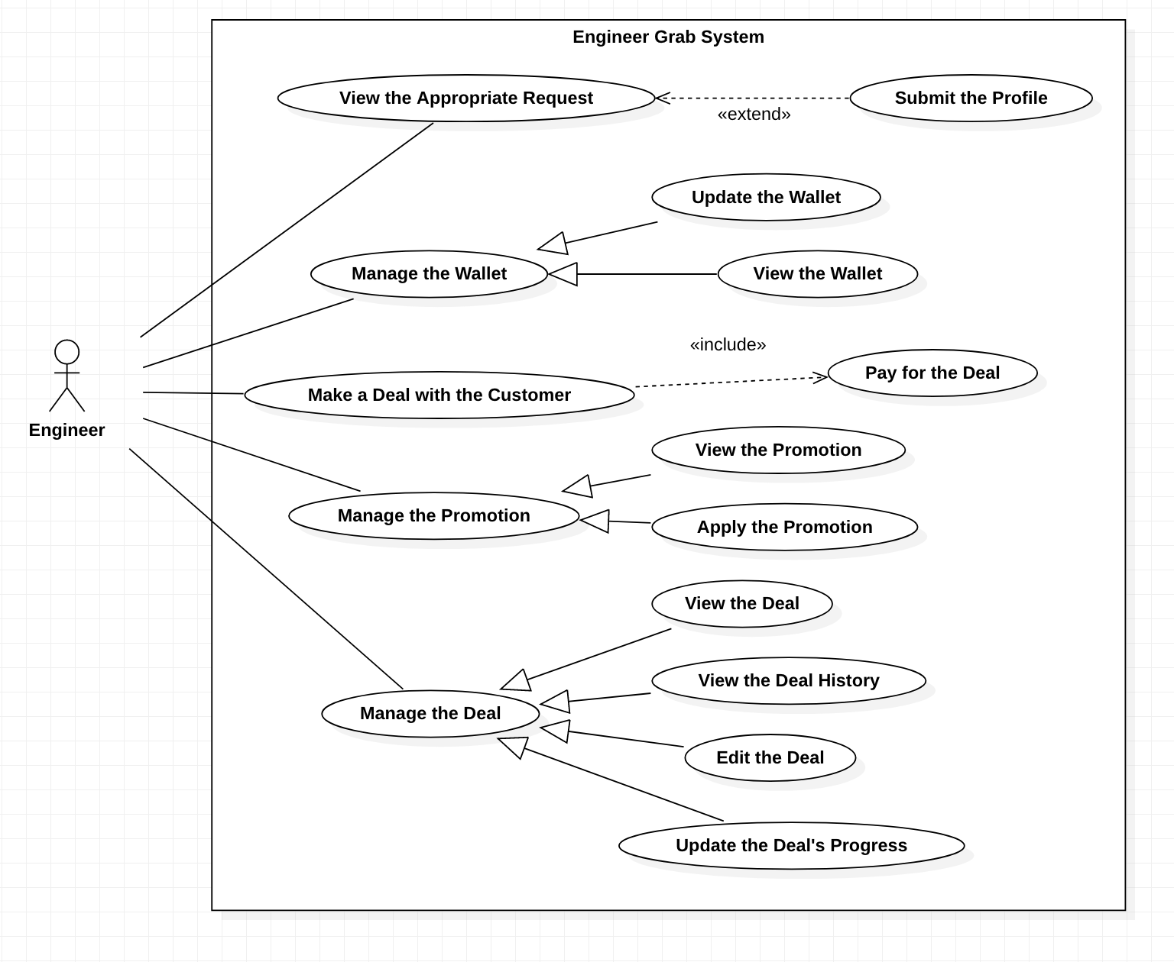

*Figure 29 - <Engineer> Overview Use Case*

#### 2.4.1 <Engineer> View the Appropriate Request

**Use Case Diagram**

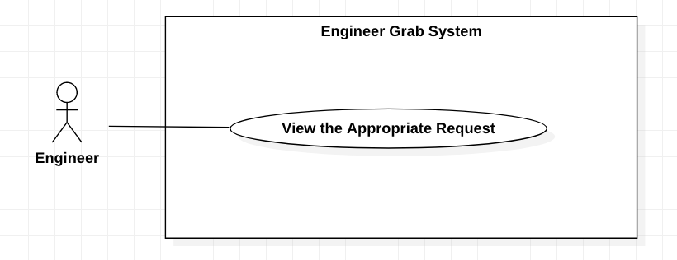

*Figure 30 - <Engineer> View the Appropriate Request*

**Use Case Specifications**

|  |  |  |  |
| --- | --- | --- | --- |
| **USE CASE – Engineer Grab System** | | | |
| **Use Case No.** | EGS-26 | **Use Case Version** | 1.0 |
| **Use Case Name** | View the Approprivate Request | | |
| **Author** | Do Ngoc Huu | | |
| **Date** | 30/03/2020 | **Priority** | Normal |
| **Actor:**  - Engineer.  **Summary:**  - This use case allows the engineer to view the appropriate request.  **Goal:**  - Engineer can view the appropriate request.  **Triggers:**  - Engineer clicks on the appropriate request link.  **Preconditions:**  - Engineer must login to the system.  - Engineer is on the Home page.  **Postconditions:**  - **Success**: Engineer shows the appropriate request details successfully.  - **Fail**: System shows the error message.  **Main Success Scenarios:**   |  |  |  | | --- | --- | --- | | **Step** | **Actor Action** | **System Response** | | 1 | Engineer clicks on the appropriate request link. | System shows the request details that includes:   * Title. * Content. * Image * Created time. * City. * District. * Requested time. * Service. * Promotion.   [Exception 1] |   **Alternative Scenarios:** N/A  **Exceptions:**   |  |  |  | | --- | --- | --- | | **No** | **Actor Action** | **System Response** | | 1 | The request is not available. | System shows the message: “This request is not available”. | | 2 | Internet problem. | System shows the message: "The system is busy" when the internet is lost. |   **Relationships:** N/A  **Business Rules:**  - The Engineer’s career is matched the request’s service.  - The Engineer can view the request that has “Active” status.  - The requests must be sorted by ascending request time.  - The requests must be paging. | | | |

*Table 27 - <Engineer > View the Appropriate Request*

#### 2.4.2 <Engineer> Submit the Profile

**Use Case Diagram**

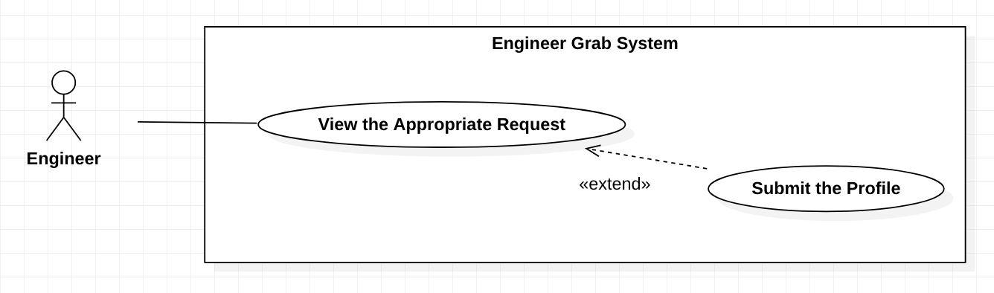

*Figure 31 - <Engineer> Submit the Profile*

**Use Case Specifications**

|  |  |  |  |
| --- | --- | --- | --- |
| **USE CASE – Engineer Grab System** | | | |
| **Use Case No.** | EGS-27 | **Use Case Version** | 1.0 |
| **Use Case Name** | Submit the Profile | | |
| **Author** | HuyTQ | | |
| **Date** | 05/03/2020 | **Priority** | High |
| **Actor:**  - Engineer.  **Summary:**  - This use case allows the engineer to submit the profile.  **Goal:**  - Engineer can submit the profile.  **Triggers:**  - Engineer clicks on the “Submit” button.  **Preconditions:**  - Engineer must login to the system.  - Engineer is on the appropriate request details page.  **Postconditions:**  - **Success**: Engineer submits profile successfully.  - **Fail**: System shows the error message.  **Main Success Scenarios:**   |  |  |  | | --- | --- | --- | | **Step** | **Actor Action** | **System Response** | | 1 | Engineer clicks on the” Submit” button below the request. | System shows the message: “Submitted successfully”.  [Exception 1] |   **Alternative Scenarios:** N/A  **Exceptions:**   |  |  |  | | --- | --- | --- | | **No** | **Actor Action** | **System Response** | | 1 | The request is not available. | System shows the message: “The request is available”. | | 2 | Internet problem. | System shows the message "The system is busy" when the internet is lost. |   **Relationships:** This use case extends from the “View the Appropriate Request” use case.  **Business Rules:**  - The engineers' career must match to the request’s service.  - System will notify the message to the customer: “There is a submitted profile”. | | | |

*Table 28 - <Engineer > Submit the Profile*

#### 2.4.3 <Engineer> Make a Deal with the Customer

**Use Case Diagram**

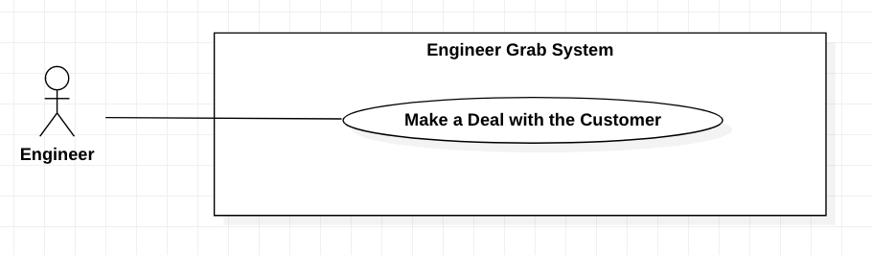

*Figure 32 - <Engineer> Make a Deal with the Customer*

**Use Case Specifications**

|  |  |  |  |
| --- | --- | --- | --- |
| **USE CASE – Engineer Grab System** | | | |
| **Use Case No.** | EGS-28 | **Use Case Version** | 1.0 |
| **Use Case Name** | Make a deal with the customer | | |
| **Author** | HuuDN | | |
| **Date** | 30/03/2020 | **Priority** | High |
| **Actor:**  - Engineer.  **Summary:**  - This use case allows the engineer to make a deal with the customer.  **Goal:**  - Engineer makes a deal.  **Triggers:**  - Engineer clicks on the “Accept” button.  **Preconditions:**  - Engineer must login to the system.  - A submitted engineer’s profile has been accepted by a customer.  **Postconditions:**  - **Success**: Engineer makes a deal successfully.  - **Fail**: System shows the error message.  **Main Success Scenarios:**   |  |  |  | | --- | --- | --- | | **Step** | **Actor Action** | **System Response** | | 1 | Engineer clicks on the “Confirm” button. | System shows the successful dialog that includes:  + Title  + Content  + Image + Requestor’s name.  + Requestor’s phone.  + Requestor’s address.  + City.  + District.  + Requested time.  + Service.  + Promotion details.  + Accepted deal time.  [Exception 1] |   **Alternative Scenarios:** N/A  **Exceptions:**   |  |  |  | | --- | --- | --- | | **No** | **Actor Action** | **System Response** | | 1 | The request is not available. | System shows the message: “This request is not available.” | | 2 | Internet problem. | System shows the message: "The system is busy" when the internet is lost. |   **Relationships:** N/A  **Business Rules:**  - Do not allow the engineer to press confirm when the engineer has another deal 1 hour before or after the requested time of this deal.  - After making the deal, the engineer must pay money for this deal to complete.  - Before the requested time, the deal's progress is changed to "Pending repair".  - At the request time, the deal's progress is changed to "In repair". | | | |

*Table 29 - <Engineer > Make a Deal with the Customer*

#### 2.4.4 <Engineer> Pay for the Deal

**Use Case Diagram**

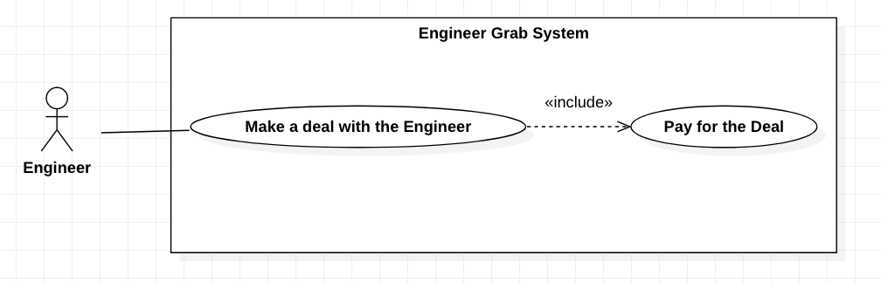

*Figure 33 - <Engineer> Pay for the Deal*

**Use Case Specifications**

|  |  |  |  |
| --- | --- | --- | --- |
| **USE CASE – Engineer Grab System** | | | |
| **Use Case No.** | EGS-29 | **Use Case Version** | 1.0 |
| **Use Case Name** | Pay for the Deal | | |
| **Author** | Do Ngoc Huu | | |
| **Date** | 30/03/2020 | **Priority** | High |
| **Actor:**  - Engineer.  **Summary:**  - This use case allows the engineer to pay for the deal.  **Goal:**  - Engineer pays money to make the deal with the customer.  **Triggers:**  - Engineer clicks on the “Accept” button while making the deal.  **Preconditions:**  - Engineer must login to the system.  - A submitted engineer’s profile has been accepted by a customer.  **Postconditions:**  - **Success**: Engineer make a deal successfully.  - **Fail**: System shows the error message.  **Main Success Scenarios:**   |  |  |  | | --- | --- | --- | | **Step** | **Actor Action** | **System Response** | | 1 | Engineer clicks on the “Submit” button. | System shows the message: “Payment is completed.”  [Exception 1] |   **Alternative Scenarios:** N/A  **Exceptions:**   |  |  |  | | --- | --- | --- | | **No** | **Actor Action** | **System Response** | | 1 | Engineer's wallet does not enough money to pay. | System shows the message: “Your wallet does not enough money.”. | | 2 | Internet problem. | System shows the message: "The system is busy" when the internet is lost. |   **Relationships:** This use case includes the “Make a deal with Customer” use case.  **Business Rules:**  - Engineer can apply a promotion for this deal.  - After payment successfully, this engineer’s wallet is updated. | | | |

*Table 30 - <Engineer > Pay for the Deal*

#### 2.4.5 <Engineer> Update the Wallet

**Use Case Diagram**

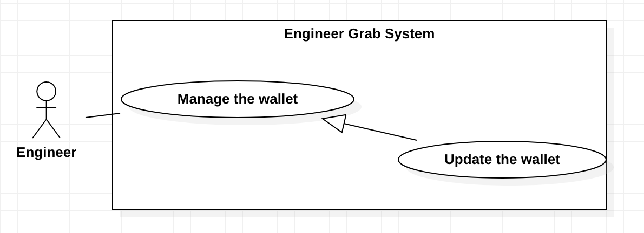

*Figure 34 - <Engineer> Update the Wallet*

**Use Case Specifications**

|  |  |  |  |
| --- | --- | --- | --- |
| **USE CASE - Engineer Grab System** | | | |
| **Use Case No.** | EGS-30 | **Use Case Version** | 1.0 |
| **Use Case Name** | Update the wallet | | |
| **Author** | TruongTN | | |
| **Date** | 23/02/2020 | **Priority** | High |
| **Actor:**  - Engineer  **Summary:**  - This use case allows the engineer to update the wallet.  **Goal:**  - Engineer can update the wallet.  **Triggers:**  - Engineer clicks on the “Update the wallet” button.  **Preconditions:**  - Engineer must login to the system.  **Postconditions:**  - **Success**: Engineer updates the wallet successfully.  - **Fail**: System shows the error message.  **Main Success Scenario:**   |  |  |  | | --- | --- | --- | | **Step** | **Actor Action** | **System Response** | | 1 | Engineer clicks “Update the wallet” on navigation menu. | System redirects to update the wallet screen. | | 2 | Engineer inputs the “Trading Code” field. |  | | 3 | Engineer clicks on the “Confirm” button. | System shows the message that the wallet is updated.  [Exception 1] |   **Alternative Scenarios:** N/A  **Exceptions:**   |  |  |  | | --- | --- | --- | | **No** | **Actor Action** | **System Response** | | 1 | Engineer inputs the invalid ”Trading Code” field. | System shows the message: “Tranding code is not avaliable.”. | | 2 | Internet problem. | System shows the message: "System is busy" when the internet is lost. |   **Relationships:** N/A  **Business Rules:**  - The balance of the wallet is updated with the current balance plus cost of trading code.  - After updated successfully, the updated time is stored.  - System redirects to view the wallet screen. | | | |

*Table 31 - <Engineer > Update the wallet*

#### 2.4.6 <Engineer> View the Wallet

**Use Case Diagram**

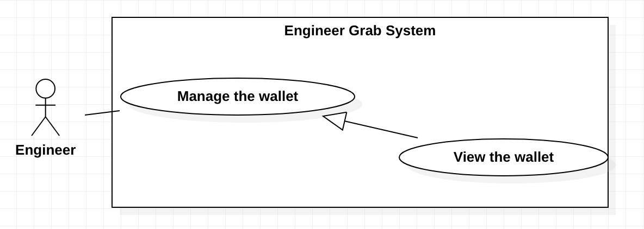

*Figure 35 - <Engineer> View the Wallet*

**Use Case Specifications**

|  |  |  |  |
| --- | --- | --- | --- |
| **USE CASE - Engineer Grab System** | | | |
| **Use Case No.** | EGS-31 | **Use Case Version** | 1.0 |
| **Use Case Name** | View the wallet | | |
| **Author** | TruongTN | | |
| **Date** | 23/02/2020 | **Priority** | Normal |
| **Actor:**  - Engineer  **Summary:**  - This use case allows the engineer to view the wallet.  **Goal:**  - Engineer can view the wallet.  **Triggers:**  - Engineer clicks on the “My wallet” button.  **Preconditions:**  - Engineer must login to the system.  **Post conditions:**  - **Success**: Engineer view the wallet details successfully .  - **Fail**: System shows the error message.  **Main Success Scenario:**   |  |  |  | | --- | --- | --- | | **Step** | **Actor Action** | **System Response** | | 1 | Engineer clicks “View the wallet” on navigation menu. | System redirects to view the wallet screen with the wallet details. |   **Alternative Scenarios:** N/A  **Exceptions:**   |  |  |  | | --- | --- | --- | | **No** | **Actor Action** | **System Response** | | 1 | Internet problem. | System shows the message: "System is busy" when the internet is lost. |   **Relationships:** N/A  **Business Rules:**  - The wallet details display base on the engineer’s id.  - The wallet details must have:   1. Balance 2. Updated time | | | |

*Table 32 - <Engineer > View the wallet*

#### <Engineer> View the Deal

**Use Case Diagram**

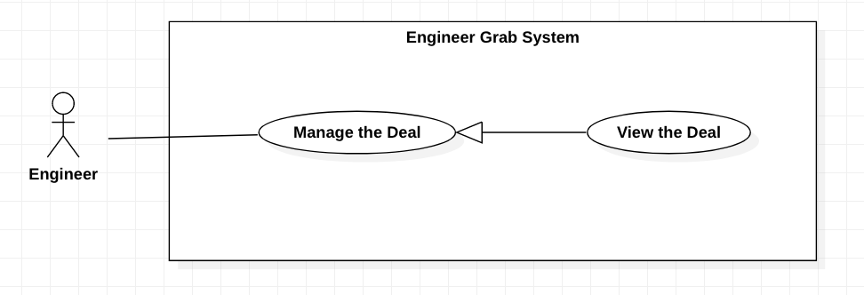

*Figure 36 - <Engineer> View the Deal*

**Use Case Specifications**

|  |  |  |  |
| --- | --- | --- | --- |
| **USE CASE – Engineer Grab System** | | | |
| **Use Case No.** | EGS-32 | **Use Case Version** | 1.0 |
| **Use Case Name** | View the Deal | | |
| **Author** | HuuDN | | |
| **Date** | 30/03/2020 | **Priority** | Normal |
| **Actor:**  - Engineer.  **Summary:**  - This use case allows the engineer to view the deal details.  **Goal:**  - Engineer can view the deal details.  **Triggers:**  - Engineer clicks on the “Manage Deal” button on navigation menu.  **Preconditions:**  - Engineer must login to the system.  **Postconditions:**  - **Success**: Customer views the deal details.  - **Fail**: System shows the error message.  **Main Success Scenarios:**   |  |  |  | | --- | --- | --- | | **Step** | **Actor Action** | **System Response** | | 1 | Engineer clicks on the “Manage Deal” button on navigation menu. | System shows the list of the deals details that have “pending repair” or “in repair” progress.  [Exception 1] | | 2 | Engineer clicks on the deal link. | System shows the deal details that includes:  + Title.  + Content.  + Image. + Requestor’s name.  + Requestor’s phone.  + Requestor’s address.  + City.  + District.  + Requested time  + Poster  + Deal’s progress.  + Service.  + Promotion.  + Accepted deal time.  [Exception 2] |   **Alternative Scenarios:** N/A  **Exceptions:**   |  |  |  | | --- | --- | --- | | **No** | **Actor Action** | **System Response** | | 1 | List of the deals that have “pending repair” or “in repair” progress is empty. | System shows the message: “You do not have a deal.” | | 2 | The deal is not available. | System shows the message: “This deal is not available”. | | 3 | Internet problem. | System shows the message: "System is busy" when the internet is lost. |   **Relationships:** N/A  **Business Rules:**  - The deals must be sorted by ascending requested time.  - The deals must be paging. | | | |

*Table 33 - <Engineer > View the Deal*

#### <Engineer> Edit the Deal

**Use Case Diagram**

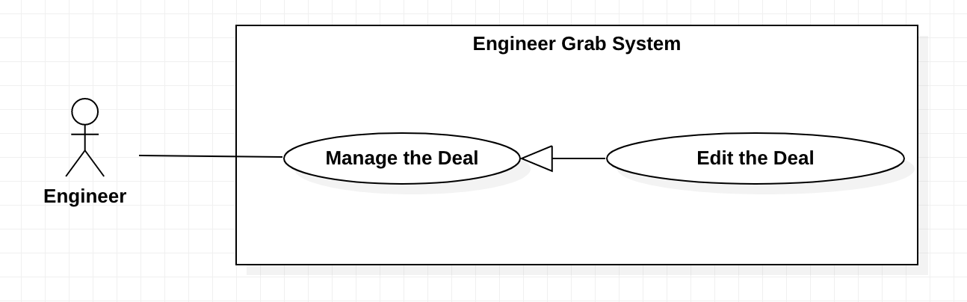

*Figure 37 - <Engineer> Edit the Deal*

**Use Case Specifications**

|  |  |  |  |
| --- | --- | --- | --- |
| **USE CASE – Engineer Grab System** | | | |
| **Use Case No.** | EGS-33 | **Use Case Version** | 1.0 |
| **Use Case Name** | Edit the Deal | | |
| **Author** | HuuDN | | |
| **Date** | 30/03/2020 | **Priority** | Normal |
| **Actor:**  - Engineer.  **Summary:**  - This use case allows the engineer to edit the deal details.  **Goal:**  - Engineer can edit the deal details.  **Triggers:**  - Engineer clicks on the “Edit” button below the deal details.  **Preconditions:**  - Engineer must login to the system.  - Engineer must have a deal that has “Pending repair” progress.  - Engineer is on the deal details page.  **Postconditions:**  - **Success**: Engineer edits the deal details successfully.  - **Fail**: System shows the error message.  **Main Success Scenarios:**   |  |  |  | | --- | --- | --- | | **Step** | **Actor Action** | **System Response** | | 1 | Engineer clicks on the “Edit” button below the deal details. | System shows the form that includes:  + Promotion: input  [Exception 1] | | 2 | Engineer inputs the promotion’s name. |  | | 3 | Engineer clicks on the “Submit” button. | System shows the successful message: “Edit successfully”.  [Exception 1,2] |   **Alternative Scenarios:** N/A  **Exceptions:**   |  |  |  | | --- | --- | --- | | **No** | **Actor Action** | **System Response** | | 1 | The deal is not available. | System shows the message: “This deal is not available”. | | 2 | The promotion is not available | System shows the message: “The promotion is not available.”. | | 3 | Internet problem. | System shows the message: "The system is busy" when the internet is lost. |   **Relationships:** N/A  **Business Rules:**  - A promotion is only applied to a deal.  - After the deal is edited, system will update the balance in the engineer's wallet.  - System redirects to the deal details page. | | | |

*Table 34 - <Engineer > Edit the Deal*

#### <Engineer> Update the Deal’s Progress

**Use Case Diagram**

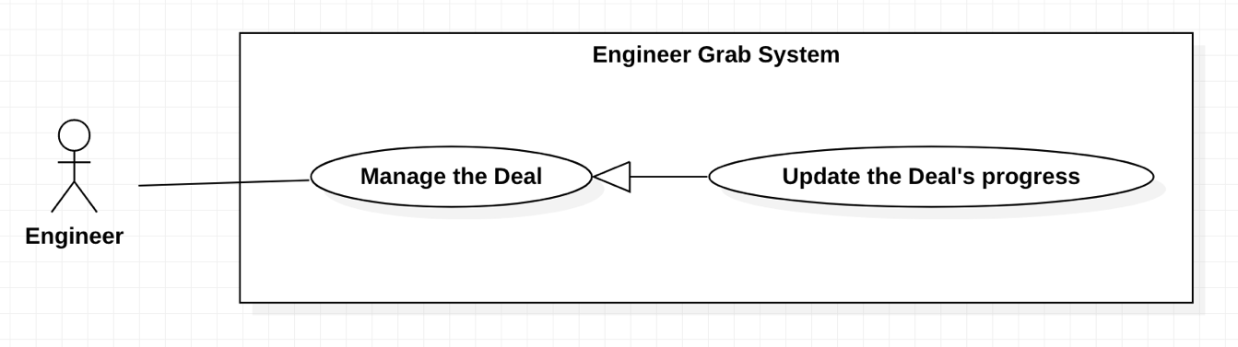

*Figure 38 - <Engineer> Update the Deal’s progress*

**Use Case Specifications**

|  |  |  |  |
| --- | --- | --- | --- |
| **USE CASE – Engineer Grab System** | | | |
| **Use Case No.** | EGS-34 | **Use Case Version** | 1.0 |
| **Use Case Name** | Update the Deal’s progress | | |
| **Author** | HuuDN | | |
| **Date** | 30/03/2020 | **Priority** | High |
| **Actor:**  - Engineer.  **Summary:**  - This use case allows the engineer to update the deal’s progress.  **Goal:**  - Engineer can update the deal’s progress.  **Triggers:**  - Engineer clicks on the “Cancel” button below the detais of a deal that has “pending repair” progress.  - Engineer clicks on the “Complete” button below the details of a deal that has “in repair” progress.  **Preconditions:**  - Engineer must login to the system.  - Engineer must have a deal that has “pending repair” or “in repair” progress.  - Engineer is on the deal details page.  **Postconditions:**  - **Success**: Engineer updates the deal’s progress successfully.  - **Fail**: System shows the error message.  **Main Success Scenarios:**   |  |  |  | | --- | --- | --- | | **Step** | **Actor Action** | **System Response** | | 1 | Engineer clicks on the “Cancel” button below the deal details.  [Alternative 1] | System asks the engineer to confirm the action.  [Exception 1] | | 2 | Engineer chooses to confirm the action. | System shows the successful message. |   **Alternative Scenarios:**   |  |  |  | | --- | --- | --- | | **Step** | **Actor Action** | **System Response** | | 1 | Engineer clicks on the “Complete” button below the deal details. | System asks the engineer to confirm the action. |   **Exceptions:**   |  |  |  | | --- | --- | --- | | **No** | **Actor Action** | **System Response** | | 1 | The deal is not available. | System shows the message: “This deal is not available”. | | 2 | Internet problem. | System shows the message: "System is busy" when the internet is lost. |   **Relationships:** N/A  **Business Rules:**  - Engineer can only cancel the deals that have “Pending repair” progress.  - After the deal is canceled, the request’s status of this deal is changed to “Active”.  - After the deal is canceled, the status of this deal is changed to “Canceled” and system will notify the customer.  - Engineer can only complete the deals that have “In repair” progress.  - After the deal is completed, the request’s status of this deal is changed to “Completed”.  - After the deal is completed, the status of this deal is changed to “Completed”.  - System redirects to the deal details page. | | | |

*Table 35 - <Engineer > Update the Deal’s progress*

#### <Engineer> View the Deal History

**Use Case Diagram**

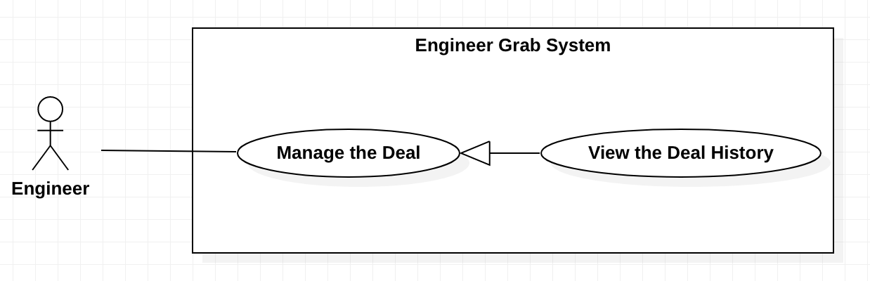

*Figure 39 - <Engineer> View the Deal History*

**Use Case Specifications**

|  |  |  |  |
| --- | --- | --- | --- |
| **USE CASE – Engineer Grab System** | | | |
| **Use Case No.** | EGS-35 | **Use Case Version** | 1.0 |
| **Use Case Name** | View the Deal History | | |
| **Author** | HuuDN | | |
| **Date** | 30/03/2020 | **Priority** |  |
| **Actor:**  - Engineer.  **Summary:**  - This use case allows the engineer to view the deal history.  **Goal:**  - Engineer can view the deal history.  **Triggers:**  - Engineer clicks on the “Deal History” button on navigation menu.  **Preconditions:**  - Engineer must login to the system.  **Postconditions:**  - **Success**: Engineer the deal history details successfully.  - **Fail**: System shows the error message.  **Main Success Scenarios:**   |  |  |  | | --- | --- | --- | | **Step** | **Actor Action** | **System Response** | | 1 | Engineer clicks on the “Deal History” button on navigation menu. | System shows the list of the deals details that have “completed” or “canceled” progress.  [Exception 1] | | 2 | Engineer clicks on the completed deal link.  [Alternative 1] | System shows the deal details that includes:  + Title  + Content  + Image + Requestor’s name  + Requestor’s phone  + Requestor’s address  + City  + District  + Requested time  + Poster  + Deal’s progress  + Service  + Promotion  + Accepted deal time  + Completed deal time  [Exception 2] |   **Alternative Scenarios:**   |  |  |  | | --- | --- | --- | | **Step** | **Actor Action** | **System Response** | | 1 | Engineer clicks on the canceled deal link. | System shows the deal details that includes:  + Title  + Content  + Image  + Poster  + Deal’s progress  + Service  + Promotion  + Accepted deal time  + Canceled deal time  [Exception 2] |   **Exceptions:**   |  |  |  | | --- | --- | --- | | **No** | **Actor Action** | **System Response** | | 1 | List of the deals details that have “completed” or “canceled” progress is empty. | System shows the message: “You do not have a deal”. | | 2 | The deal is not available. | System shows the message: “This deal is not available”. | | 2 | Internet problem. | System shows the message: "System is busy" when the internet is lost. |   **Relationships:** N/A  **Business Rules:**  - The deals must be sorted by descending completed and canceled time.  - The deals must be paging. | | | |

*Table 36 - <Engineer > View the Deal History*

#### <Engineer> View the Promotion

**Use Case Diagram**

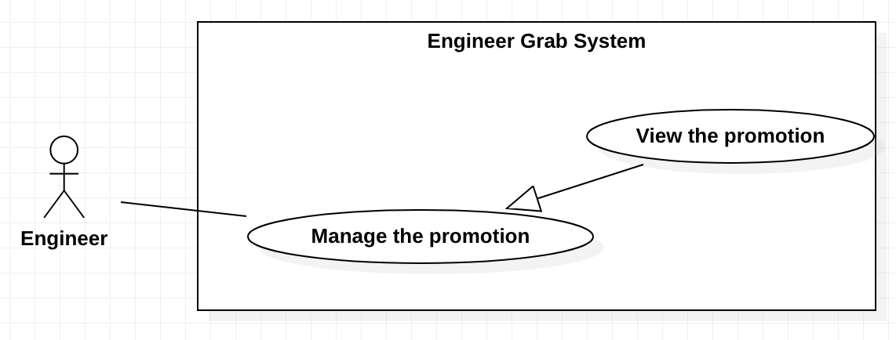

*Figure 39 - <Engineer> View the Promotion*

**Use Case Specifications**

|  |  |  |  |
| --- | --- | --- | --- |
| **USE CASE - Engineer Grab System** | | | |
| **Use Case No.** | EGS-36 | **Use Case Version** | 1.0 |
| **Use Case Name** | View the promotion | | |
| **Author** | TruongTN | | |
| **Date** | 23/03/2020 | **Priority** | Normal |
| **Actor:**  - Engineer  **Summary:**  - This use case allows the engineer to view the promotion.  **Goal:**  - Engineer can view the promotion.  **Triggers:**  - Engineer clicks on the ”View the promotion” link.  **Preconditions:**  - Engineer must login to the system.  **Post conditions:**  - **Success**: Engineer views the promotion details successfully.  - **Fail**: System shows the error message.  **Main Success Scenario:**   |  |  |  | | --- | --- | --- | | **Step** | **Actor Action** | **System Response** | | 1 | Engineer clicks on “My promotion” button on navigation menu. | System redirects to view the promotion screen with a list of the promotions.  [Exception 1] | | 2 | Engineer clicks on the promotion link. | System redirects to view the promotion details screen. Engineer can view information on the promotion.  [Exception 2] |   **Alternative Scenarios:** N/A  **Exceptions:**   |  |  |  | | --- | --- | --- | | **No** | **Actor Action** | **System Response** | | 1 | Engineer does not have a promotion. | System shows the message “You have no the promotion.” | | 2 | The promotion is not available. | System shows the message: “The promotion is not available .”. | | 3 | Internet problem. | System shows the message: "System is busy" when the internet is lost. |   **Relationships:** N/A  **Business Rules:**  - The promotions must be paging.  - The promotions must be sorted by descending ended time.  - The promotion details screen must include:   1. Name of the promotion 2. Amount discount 3. Percent discount 4. Ended time 5. Status 6. Applied time | | | |

*Table 37 - <Engineer > View the Promotion*

#### <Engineer> Apply the Promotion

**Use Case Diagram**

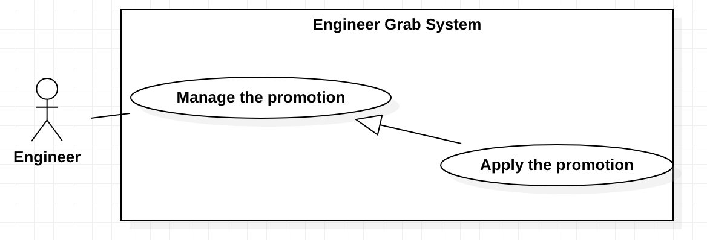

*Figure 40 - <Engineer> Apply the Promotion*

**Use Case Specifications**

|  |  |  |  |
| --- | --- | --- | --- |
| **USE CASE - Engineer Grab System** | | | |
| **Use Case No.** | EGS-37 | **Use Case Version** | 1.0 |
| **Use Case Name** | Apply the promotion | | |
| **Author** | TruongTN | | |
| **Date** | 29/03/2020 | **Priority** | High |
| **Actor:**  - Engineer  **Summary:**  - This use case allows the engineer to apply the promotion.  **Goal:**  - Engineer can apply the promotion.  **Triggers:**  - Engineer clicks on the ”Apply the promotion” button.  **Preconditions:**  - Engineer must login to the system.  - Engineer is on the deal details page.  **Post conditions:**  - **Success**: Engineer can apply the promotion successfully.  - **Fail**: System shows the error message.  **Main Success Scenario:**   |  |  |  | | --- | --- | --- | | **Step** | **Actor Action** | **System Response** | | 1 | Engineer inputs the promotion’s name. |  | | 2 | Engineer clicks on the “Apply the promotion” button. | System shows the message that the promotion is applied for this request.  [Exception 1, 2, 3] |   **Alternative Scenarios:** N/A  **Exceptions:**   |  |  |  | | --- | --- | --- | | **No** | **Actor Action** | **System Response** | | 1 | The promotion’s name is blank. | System shows the message: “The promotion’s name is required.”. | | 2 | The promotion is not available. | System shows the message: “The promotion is not available.”. | | 3 | The promotion is used. | System shows the message: “ The promotion is used.”. | | 4 | Internet problem. | System shows the message: "System is busy" when the internet is lost. |   **Relationships:** N/A  **Business Rules:**  - If the promotions have “Deleted” status or out of date, they can not apply for the request.  - After the promotion is used, the promotion’s status is changed to “Used” and system stores the applied time.  - Only deal has “Pending repair” or “In repair” status that can apply the promotions. | | | |

*Table 38 - <Engineer > Apply the Promotion*

### 2.5 <Admin> Overview Use Case

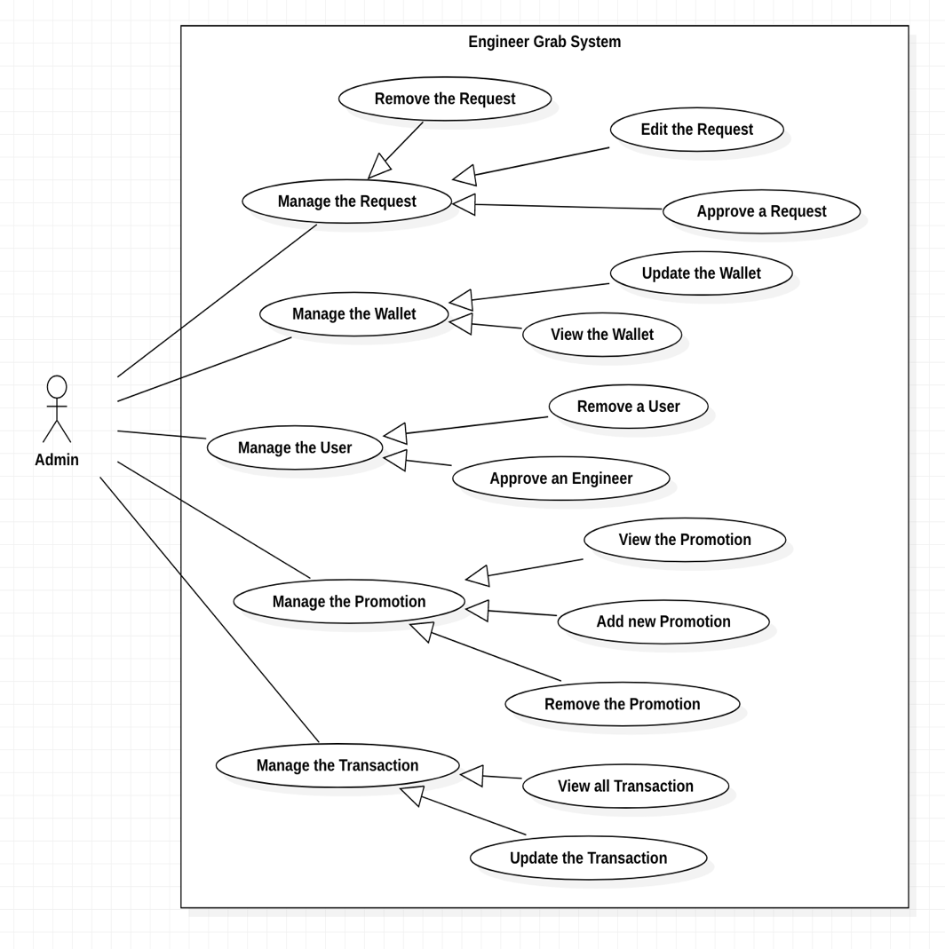

*Figure 41 - <Admin> Overview Use Case*

#### 2.5.1 <Admin> Approve an Engineer

**Use Case Diagram**

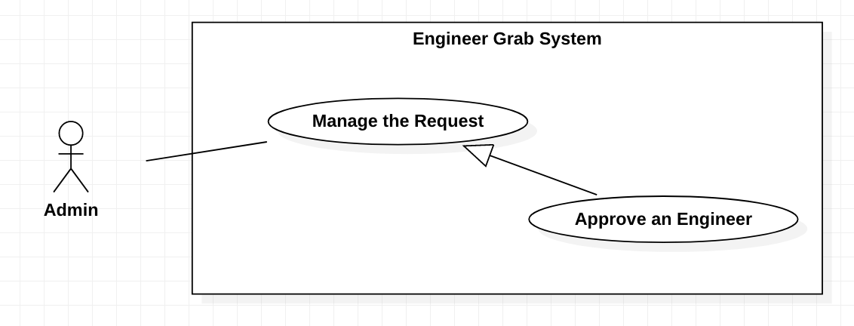

*Figure 42 - <Admin> Approve an Engineer*

**Use Case Specifications**

|  |  |  |  |
| --- | --- | --- | --- |
| **USE CASE – Engineer Grab System** | | | |
| **Use Case No.** | EGS-38 | **Use Case Version** | 1.0 |
| **Use Case Name** | Approve an Engineer | | |
| **Author** | HuyTQ | | |
| **Date** | 03/04/2020 | **Priority** | High |
| **Actor:**  - Admin.  **Summary:**  - This use case allows the admin to approve an engineer.  **Goal:**  - Admin can create an account for the engineer to use on the system.  **Triggers:**  - Admin clicks on the “Confirm” button.  **Preconditions:**  - Admin must login to the system.  - Admin has a list of the engineers who are pending approval.  - Admin is on the engineer approval page.  **Postconditions:**  - **Success**: Admin approve an engineer successfully.  - **Fail**: System shows the error message.  **Main Success Scenarios:**   |  |  |  | | --- | --- | --- | | **Step** | **Actor Action** | **System Response** | | 1 | Admin clicks on the “Confirm” button. | System shows the message: “The engineer’s account is created successfully”. |   **Alternative Scenarios:** N/A  **Exceptions:**   |  |  |  | | --- | --- | --- | | **No** | **Actor Action** | **System Response** | | 1 | Internet problem. | System shows the message: "The system is busy" when the internet is lost. |   **Relationships:** N/A  **Business Rules:**  - After adding, the engineer’s status is changed to “Active”.  - After adding, the engineer’s wallet is created. | | | |

*Table 39 - <Admin > Approve an Engineer*

#### 2.5.2 <Admin> Remove a User

**Use Case Diagram**

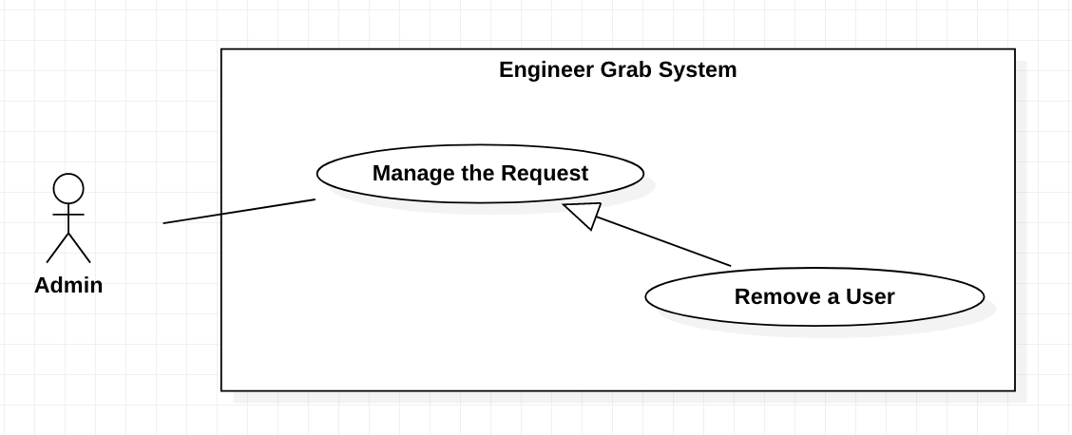

*Figure 43 - <Admin> Remove a User*

**Use Case Specifications**

|  |  |  |  |
| --- | --- | --- | --- |
| **USE CASE – Engineer Grab System** | | | |
| **Use Case No.** | EGS-39 | **Use Case Version** | 1.0 |
| **Use Case Name** | Remove a User | | |
| **Author** | HuyTQ | | |
| **Date** | 13/04/2020 | **Priority** | Normal |
| **Actor:**  - Admin.  **Summary:**  - This use case allows the admin to remove a user.  **Goal:**  - Admin can remove a user.  **Triggers:**  - Admin clicks on the “Remove” button.  **Preconditions:**  - Admin must login to the system.  - Admin has a list of the users on the manage user page.  **Postconditions:**  - **Success**: Admin removes a user successfully.  - **Fail**: System shows the error message.  **Main Success Scenarios:**   |  |  |  | | --- | --- | --- | | **Step** | **Actor Action** | **System Response** | | 1 | Admin clicks on the “Remove” button. | System ask user to confirm the action | | 2 | Admin chooses to confirm the action. | System show message that service is deleted. |   **Alternative Scenarios:** N/A.  **Exceptions:**   |  |  |  | | --- | --- | --- | | **No** | **Actor Action** | **System Response** | | 1 | Internet problem. | System shows the message "The system is busy" when the internet is lost. |   **Relationships:** N/A  **Business Rules:**   * After removing successful, the user’s status will be changed to “Deleted”. * After removing successful, system redirects to the manage user page. | | | |

*Table 40 - <Admin > Remove a User*

#### 2.5.3 <Admin> Edit the Request

**Use Case Diagram**

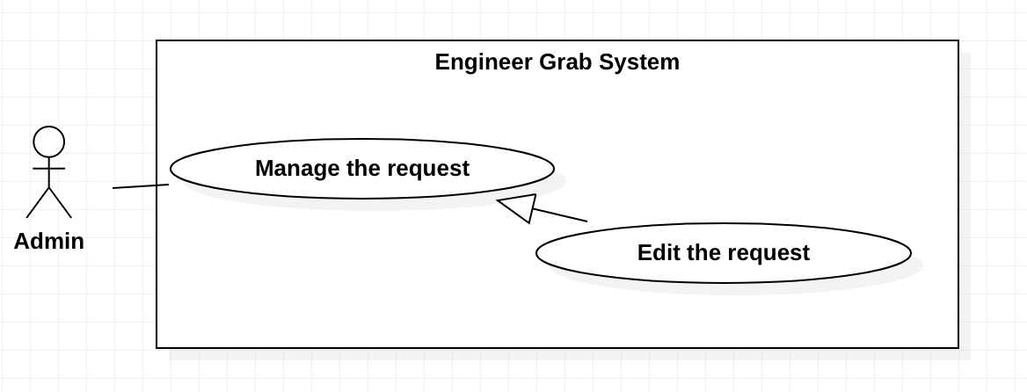

*Figure 44 - <Admin> Edit a Request*

**Use Case Specifications**

|  |  |  |  |
| --- | --- | --- | --- |
| **USE CASE – Engineer Grab System** | | | |
| **Use Case No.** | EGS-40 | **Use Case Version** | 1.0 |
| **Use Case Name** | Edit a Request | | |
| **Author** | TruongTN | | |
| **Date** | 31/03/2020 | **Priority** | Normal |
| **Actor:**  - Admin  **Summary:**  - This use case allows the admin to edit the request.  **Goal:**  - Admin can edit the request.  **Triggers:**  - Admin clicks on the “Edit” button.  **Preconditions:**  - Admin must login to the system.  - Admin has a list of the requests on the request details page  **Postconditions:**  - **Success**: Admin edits the requests successfully.  - **Fail**: System shows the error message.  **Main Success Scenario:**   |  |  |  | | --- | --- | --- | | **Step** | **Actor Action** | **System Response** | | 1 | Admin clicks on the “Edit” button on the list of requests. | System shows the form that includes:  - Status: combox  - Service: combobox | | 2 | Admin inputs or selects fields |  | | 3 | Admin clicks on the “Finish” | System shows the message that the request is edited. |   **Alternative Scenarios:** N/A  **Exceptions:**   |  |  |  | | --- | --- | --- | | **No** | **Actor Action** | **System Response** | | 1 | Internet problem. | System shows the message: "System is busy" when the internet is lost. |   **Relationships:** N/A  **Business Rules:**  - System redirects to the request details screen. | | | |

*Table 41 - <Admin > Edit a Request*

#### 2.5.4 <Admin> Approve a Request

**Use Case Diagram**

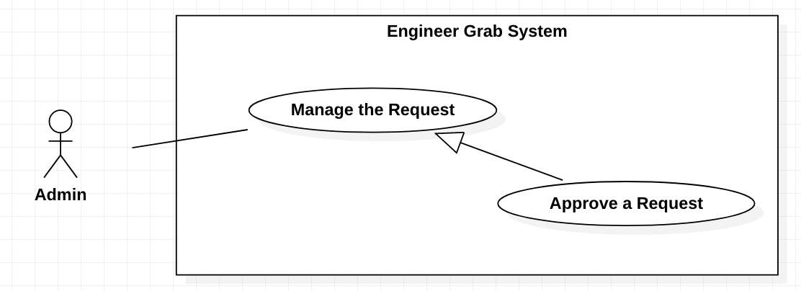

*Figure 45 - <Admin> Approve a Request*

**Use Case Specifications**

|  |  |  |  |
| --- | --- | --- | --- |
| **USE CASE – Engineer Grab System** | | | |
| **Use Case No.** | EGS-41 | **Use Case Version** | 1.0 |
| **Use Case Name** | Approve the Request | | |
| **Author** | HuyTQ | | |
| **Date** | 12/03/2020 | **Priority** | Normal |
| **Actor:**  - Admin.  **Summary:**  - This use case allows the admin to approve the request.  **Goal:**  - Admin can approve the request.  **Triggers:**  - Admin clicks on the “Approve” button.  **Preconditions:**  - This request that has “new” status exists in the system.  - Admin is on the request page.  - Admin must login the system.  **Postconditions:**  - **Success**: Admin approve the request successfully.  - **Fail**: System shows the error message.  **Main Success Scenarios:**   |  |  |  | | --- | --- | --- | | **Step** | **Actor Action** | **System Response** | | 1 | Admin clicks on the “Approve” button. | System shows the message: “Approved successfully”.  [Exception 1] |   **Alternative Scenarios:** N/A  **Exceptions:**   |  |  |  | | --- | --- | --- | | **No** | **Actor Action** | **System Response** | | 1 | The request is not available. | System shows the message: “The request is not available”. | | 2 | Internet problem. | System shows the message: "The system is busy" when the internet is lost. |   **Relationships:** N/A  **Business Rules:**  - If the request is accepted, the status of request will be changed: “Active”. | | | |

*Table 42 - <Admin > Approve a Request*

#### 2.5.5 <Admin> Add new Promotion

**Use Case Diagram**

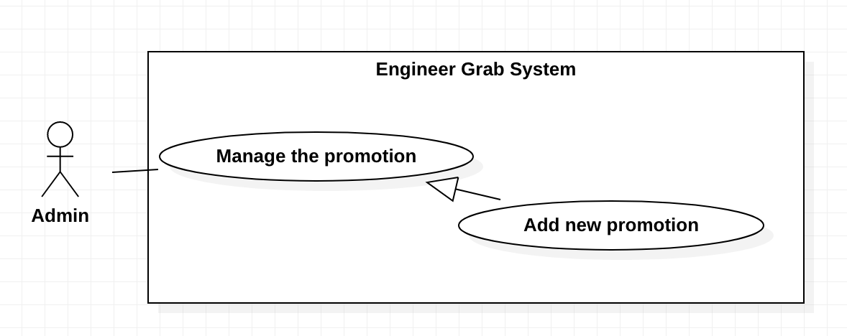

*Figure 46 - <Admin> Add new Promotion*

**Use Case Specifications**

|  |  |  |  |
| --- | --- | --- | --- |
| **USE CASE – Engineer Grab System** | | | |
| **Use Case No.** | EGS-42 | **Use Case Version** | 1.0 |
| **Use Case Name** | Add new Promotion | | |
| **Author** | TruongTN | | |
| **Date** | 30/03/2020 | **Priority** | High |
| **Actor:**  - Admin  **Summary:**  - This use case allows the admin to create new promotion.  **Goal:**  - Admin can create new promotion.  **Triggers:**  - Admin clicks on the “Create new promotion” button.  **Preconditions:**  - Admin must login to the system.  **Postconditions:**  - **Success**: Admin create new promotion successfully.  - **Fail**: System shows the error message.  **Main Success Scenario:**   |  |  |  | | --- | --- | --- | | **Step** | **Actor Action** | **System Response** | | 1 | Admin clicks on the “Create new promotion” button on navigation menu. | System shows the form that includes:  - Promotion name: input  - Discount amount: input.  - Discount percent: input.  - Started date: calendar.  - Ended date: calendar. | | 2 | Admin inputs or selects the fields. |  | | 3 | Admin clicks on the “Finish” button. | System shows the message that the promotion is created.  [Exception 1] |   **Alternative Scenarios:** N/A  **Exceptions:**   |  |  |  | | --- | --- | --- | | **No** | **Actor Action** | **System Response** | | 1 | Admin inputs invalid fields. | System shows the message with the corresponding fields:  - Promotion name: must be inputted from 5 to 60 chacracter.  - Promotion name: must not duplicate.  - Discount amount: must be an integer.  - Discount percent: must be a number.  - Started date: must be greater or equal to the current date.  - Ended date: must be greater than the started date. | | 2 | Internet problem. | System shows the message: "System is busy" when the internet is lost. |   **Relationships:** N/A  **Business Rules:**  - Admin can view the details of promotion before click the “Finish” button.  - System redirects to the promotion details screen. | | | |

*Table 43 - <Admin > Add new Promotion*

#### 2.5.6 <Admin> Edit the Promotion

**Use Case Diagram**

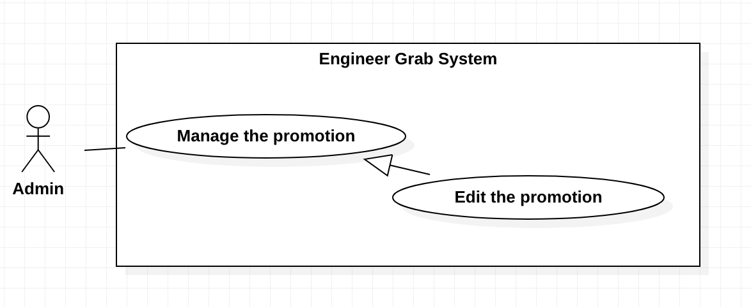

*Figure 47 - <Admin> Edit the Promotion*

**Use Case Specifications**

|  |  |  |  |
| --- | --- | --- | --- |
| **USE CASE – Engineer Grab System** | | | |
| **Use Case No.** | EGS-43 | **Use Case Version** | 1.0 |
| **Use Case Name** | Edit the Promotion | | |
| **Author** | TruongTN | | |
| **Date** | 30/03/2020 | **Priority** | Normal |
| **Actor:**  - Admin  **Summary:**  - This use case allows the admin to edit the promotion.  **Goal:**  - Admin can edit the promotion.  **Triggers:**  - Admin clicks on the “Edit” button.  **Preconditions:**  - Admin must login to the system.  - Admin has a list of the promotions on the promotion details screen.  **Postconditions:**  - **Success**: Admin edits the promotion successfully.  - **Fail**: System shows the error message.  **Main Success Scenario:**   |  |  |  | | --- | --- | --- | | **Step** | **Actor Action** | **System Response** | | 1 | Admin clicks on the “Edit” button on the list of promotions. | System shows the form include:  - Status: combobox  - Discount amout: input  - Discount persent: input  - Started date: calendar  - Ended date: calendar | | 2 | Admin inputs or selects fields. |  | | 3 | Admin clicks on the “Finish” button. | System shows the message that the promotion is edited.  [Exception 1] |   **Alternative Scenarios:** N/A  **Exceptions:**   |  |  |  | | --- | --- | --- | | **No** | **Actor Action** | **System Response** | | 1 | Admin inputs or selects invalid fields. | System shows the message with the corresponding fields:  - Discount amount: must be an integer.  - Discount percent: must be a number.  - Started date: must be greater than or equal to the current date.  - Ended date: must be greater than the started date. | | 2 | Internet problem. | System shows the message: "System is busy" when the internet is lost. |   **Relationships:** N/A  **Business Rules:**  - Admin can view the details of promotion before click the “Finish” button.  - System redirects to the promotion details screen. | | | |

*Table 44 - <Admin > Edit the Promotion*

#### <Admin> Remove the Promotion

**Use Case Diagram**

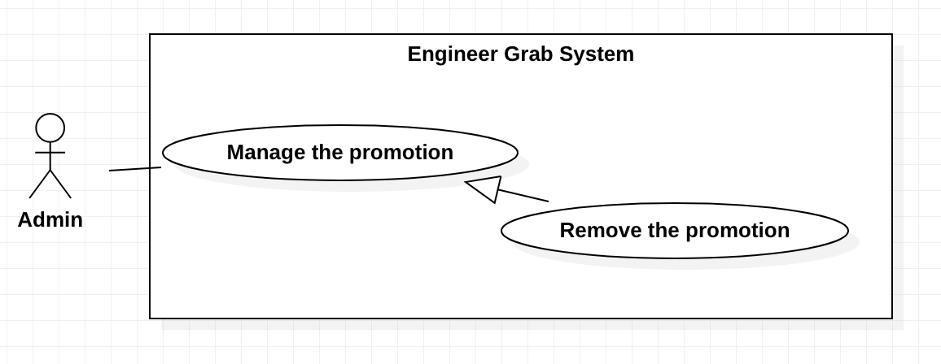

*Figure 48 - <Admin> Remove the Promotion*

**Use Case Specifications**

|  |  |  |  |
| --- | --- | --- | --- |
| **USE CASE – Engineer Grab System** | | | |
| **Use Case No.** | EGS-44 | **Use Case Version** | 1.0 |
| **Use Case Name** | Remove the Promotion | | |
| **Author** | TruongTN | | |
| **Date** | 30/03/2020 | **Priority** | Normal |
| **Actor:**  - Admin  **Summary:**  - This use case allows the admin to remove the promotion.  **Goal:**  - Admin can remove the promotion.  **Triggers:**  - Admin clicks on the “Remove” button.  **Preconditions:**  - Admin must login to the system.  - Admin has a list of the promotions on the promotion details screen.  **Postconditions:**  - **Success**: Admin removes the promotion successfully.  - **Fail**: System shows the error message.  **Main Success Scenario:**   |  |  |  | | --- | --- | --- | | **Step** | **Actor Action** | **System Response** | | 1 | Admin clicks on the “Remove” button on the list of promotions. | System asks admin to confirm the action | | 2 | Admid chooses to confirm the action. | System shows the message that the promotion is removed.  [Exception 1] |   **Alternative Scenarios:** N/A  **Exceptions:**   |  |  |  | | --- | --- | --- | | **No** | **Actor Action** | **System Response** | | 1 | Internet problem. | System shows the message: "System is busy" when the internet is lost. |   **Relationships:** N/A  **Business Rules:**  - The changing promotion status is “Deleted”.  - System redirects to the promotion details screen. | | | |

*Table 45 - <Admin > Remove the Promotion*

#### <Admin> Update the Wallet

**Use Case Diagram**

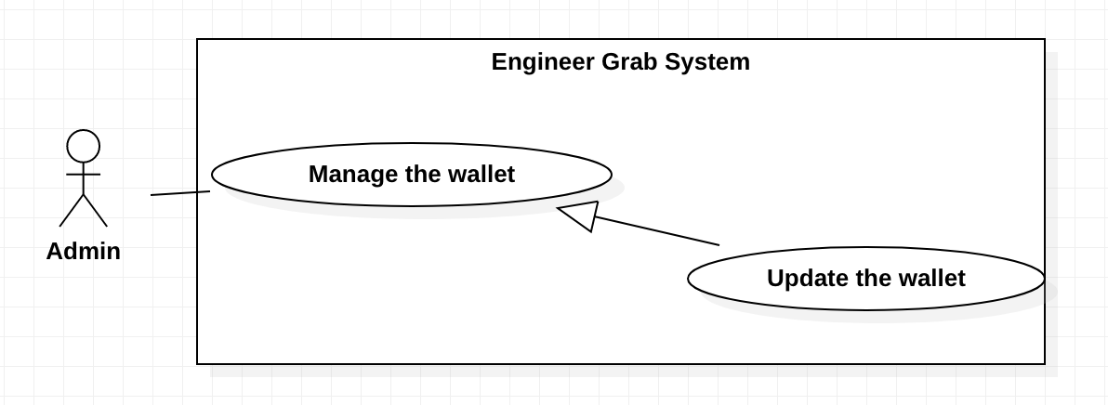

*Figure 49 - <Admin> Update the wallet*

**Use Case Specifications**

|  |  |  |  |
| --- | --- | --- | --- |
| **USE CASE – Engineer Grab System** | | | |
| **Use Case No.** | EGS-45 | **Use Case Version** | 1.0 |
| **Use Case Name** | Update the wallet | | |
| **Author** | TruongTN | | |
| **Date** | 30/03/2020 | **Priority** | High |
| **Actor:**  - Admin  **Summary:**  - This use case allows the admin to update the engineer’s wallet.  **Goal:**  - Admin can update the engineer’s wallet.  **Triggers:**  - Admin clicks on the “Update wallet” button.  **Preconditions:**  - Admin must login to the system.  - Admin is on the engineer’s wallet page.  **Postconditions:**  - **Success**: Admin updates the wallet successfully.  - **Fail**: System shows the error message.  **Main Success Scenario:**   |  |  |  | | --- | --- | --- | | **Step** | **Actor Action** | **System Response** | | 1 | Admin clicks on the “Update wallet” button. | System shows the message that the wallet is updated.  [Exception 1] |   **Alternative Scenarios:** N/A  **Exceptions:**   |  |  |  | | --- | --- | --- | | **No** | **Actor Action** | **System Response** | | 1 | The wallet is not available. | System shows the message: “The wallet is not available.”. | | 2 | Internet problem. | System shows the message: "System is busy" when the internet is lost. |   **Relationships:** N/A  **Business Rules:**  - If Engineer cancels the deal, return 90% cost of the deal is canceled.  - If Customer cancels the deal, return 100% cost of the deal is canceled.  - After updated successfully, the updated time is stored.  - System redirects to view the engineer’s wallet screen. | | | |

*Table 46 - <Admin > Update the wallet*

#### <Admin> View the Wallet

**Use Case Diagram**

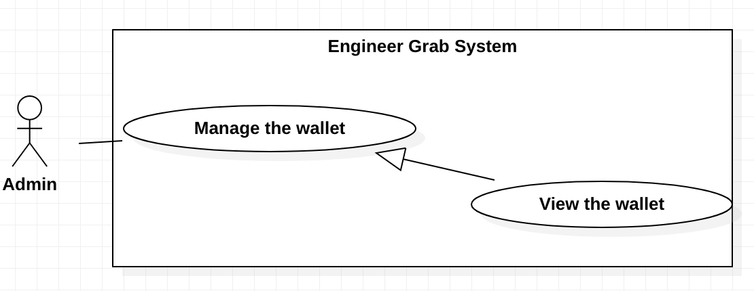

*Figure 50 - <Admin> View the wallet*

**Use Case Specifications**

|  |  |  |  |
| --- | --- | --- | --- |
| **USE CASE – Engineer Grab System** | | | |
| **Use Case No.** | EGS-46 | **Use Case Version** | 1.0 |
| **Use Case Name** | View the wallet | | |
| **Author** | TruongTN | | |
| **Date** | 29/03/2020 | **Priority** | Normal |
| **Actor:**  - Admin  **Summary:**  - This use case allows the admin to view the engineer’s wallet.  **Goal:**  - Admin can view the engineer’s wallet.  **Triggers:**  - Admin clicks on the “Manage wallet” button.  **Preconditions:**  - Admin must login to the system.  **Postconditions:**  - **Success**: Admin views the list of engineer’s wallet details successfully.  - **Fail**: System shows the error message.  **Main Success Scenario:**   |  |  |  | | --- | --- | --- | | **Step** | **Actor Action** | **System Response** | | 1 | Admin clicks on the “Manage wallet” on navigation menu. | System redirects to view the wallet screen with the list of engineer’s wallets.  [Exception 1] |   **Alternative Scenarios:** N/A  **Exceptions:**   |  |  |  | | --- | --- | --- | | **No** | **Actor Action** | **System Response** | | 1 | Admin does not have the wallet | System shows the message that “The list have no wallet” | | 2 | Internet problem. | System shows the message: "System is busy" when the internet is lost. |   **Relationships:** N/A  **Business Rules:**  - The list of engineer’s wallet must be paging.  - The list of engineer’s wallet must be sorted by ascending engineer id.  - The list of engineer’s wallet details must have:   1. Engineer id 2. Engineer name. 3. Balance. 4. Updated time. | | | |

*Table 47 - <Admin > View the wallet*

#### <Admin> View all Transaction

**Use Case Diagram**

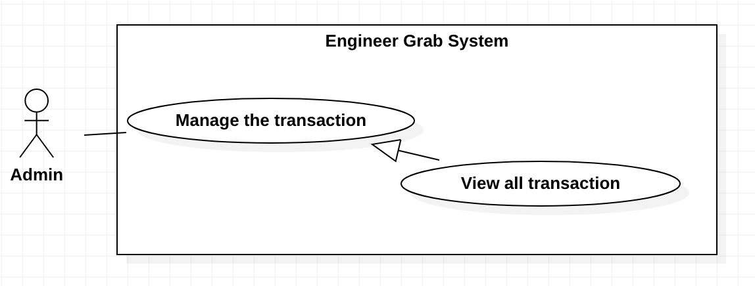

*Figure 50 - <Admin> View all transaction*

**Use Case Specifications**

|  |  |  |  |
| --- | --- | --- | --- |
| **USE CASE – Engineer Grab System** | | | |
| **Use Case No.** | EGS-47 | **Use Case Version** | 1.0 |
| **Use Case Name** | View the transaction | | |
| **Author** | TruongTN | | |
| **Date** | 29/03/2020 | **Priority** | Normal |
| **Actor:**  - Admin  **Summary:**  - This use case allows the admin to view all transaction.  **Goal:**  -Admin can view all transaction .  **Triggers:**  - Admin clicks on the “Manage transaction” button on navigation menu.  **Preconditions:**  - Admin must login to the system.  **Postconditions:**  - **Success**:Admin view all transaction successfully.  - **Fail**: System shows the error message.  **Main Success Scenario:**   |  |  |  | | --- | --- | --- | | **Step** | **Actor Action** | **System Response** | | 1 | Admin clicks on the “Manage transaction” on navigation menu. | System redirects to view all transaction screen with a list of all transaction details. [Exception 1] |   **Alternative Scenarios:** N/A  **Exceptions:**   |  |  |  | | --- | --- | --- | | **No** | **Actor Action** | **System Response** | | 1 | The list have no transaction. | System shows the message: “No transaction.” | | 2 | Internet problem. | System shows the message: "System is busy" when the internet is lost. |   **Relationships:** N/A  **Business Rules:**  - The transactions must be paging.  - The transactions must be sorted by descending checkout date.  - The transaction details screen must have:   1. Deal id 2. Request id 3. Poster id 4. Requestor’s name 5. Engineer id 6. Engineer’s name 7. Requested time 8. Checkout status 9. Checkout date 10. Completed date 11. Progress | | | |

*Table 48 - <Admin > View all transaction*

#### <Admin> Update the Transaction

**Use Case Diagram**

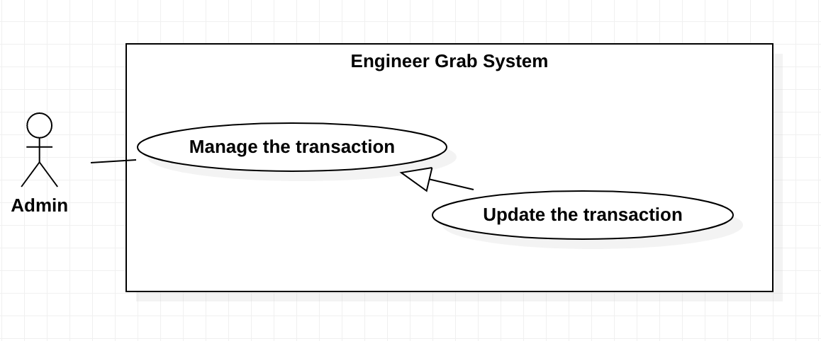

*Figure 51 - <Admin> Update all transaction*

**Use Case Specifications**

|  |  |  |  |
| --- | --- | --- | --- |
| **USE CASE – Engineer Grab System** | | | |
| **Use Case No.** | EGS-48 | **Use Case Version** | 1.0 |
| **Use Case Name** | View the transaction | | |
| **Author** | TruongTN | | |
| **Date** | 29/03/2020 | **Priority** | Normal |
| **Actor:**  - Admin  **Summary:**  - This use case allows the admin to update the transaction.  **Goal:**  - Admin can update the transaction.  **Triggers:**  - Admin clicks on the “Update transaction” button.  **Preconditions:**  - Admin must login to the system.  - Admin has a list of of transactions on view all transaction screen.  **Postconditions:**  - **Success**: Admin updates the transaction successfully.  - **Fail**: System shows the error message.  **Main Success Scenario:**   |  |  |  | | --- | --- | --- | | **Step** | **Actor Action** | **System Response** | | 1 | Admin clicks on the “Update Transaction” button on a list of transactions. | System shows the status combobox. | | 2 | Admin selects status. | System asks admin to confirm the action. | | 3 | Admid chooses to confirm the action . | System shows the message that the transaction is updated. |   **Alternative Scenarios:** N/A  **Exceptions:**   |  |  |  | | --- | --- | --- | | **No** | **Actor Action** | **System Response** | | 1 | Internet problem. | System shows the message: "System is busy" when the internet is lost. |   **Relationships:** N/A  **Business Rules:**   * The changing status of the deal is the field value that admin selected on combobox. * After updated successfully, system redirects to the view all transaction screen. | | | |

*Table 49 - <Admin > Update the transaction*

# C. Database Design

## 1. Entity relationship diagram (ERD)

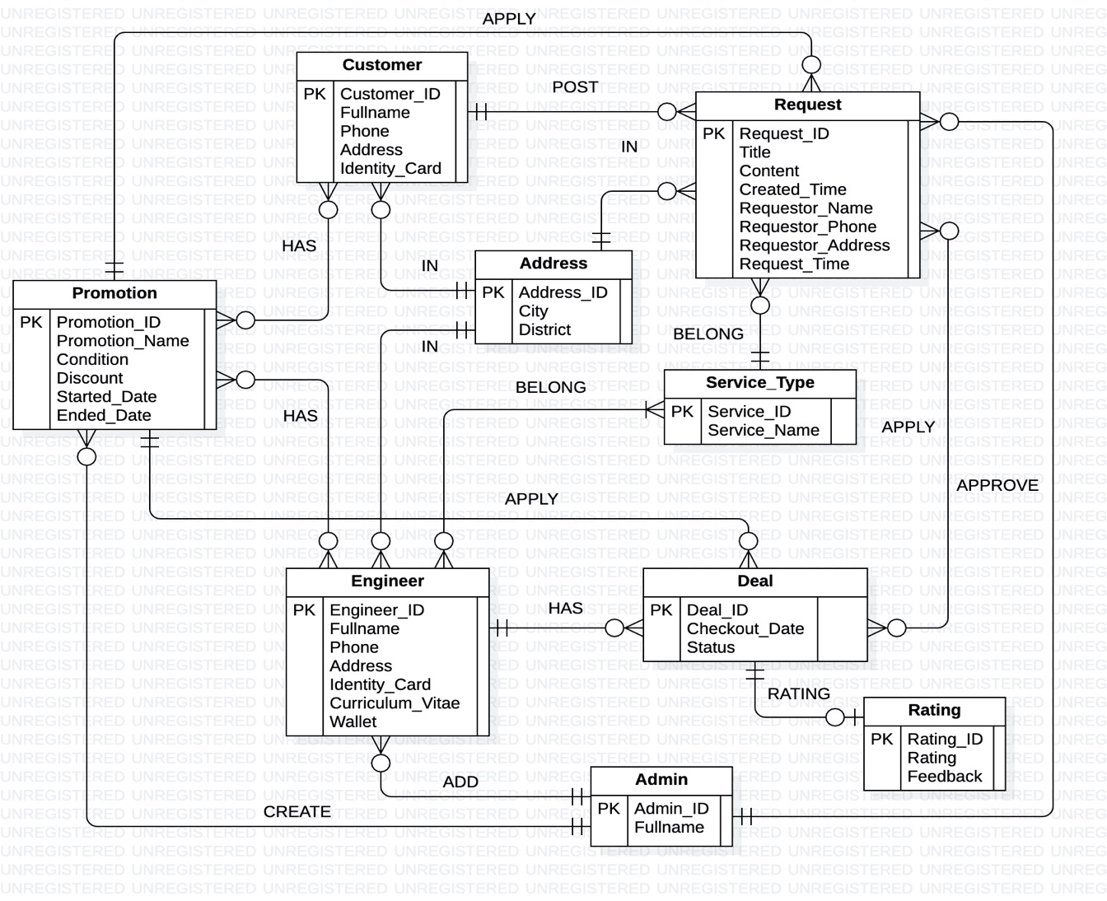

*Figure 52 - Entity relationship diagram*

## 2. Database diagram

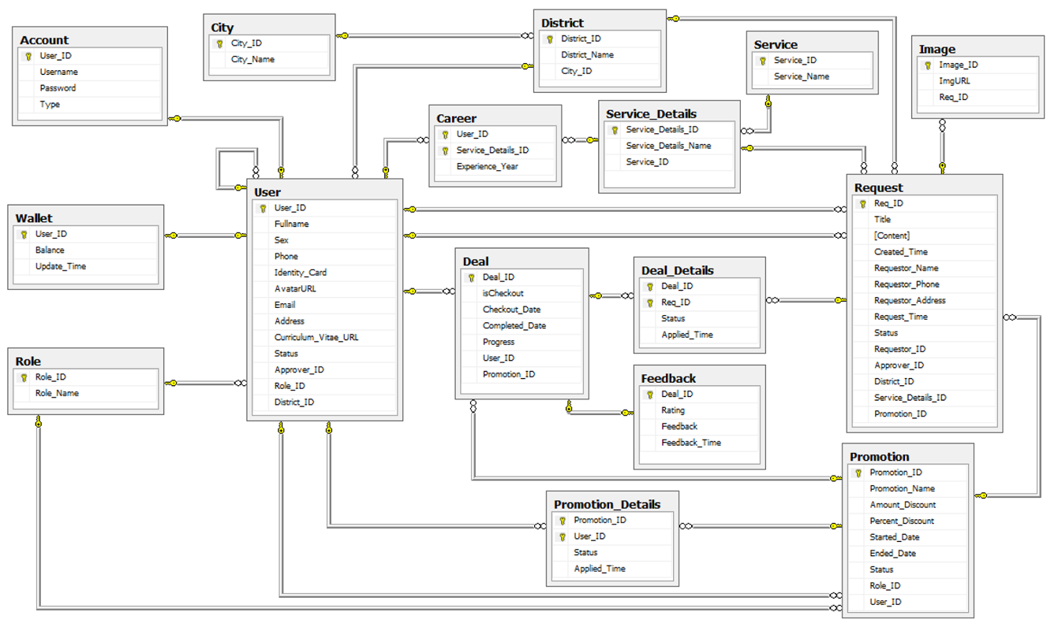

*Figure 53 - Database diagram*

## 3. Query command

### 3.1 Query command 1

Query commands use to show the list of engineers with a rating of 9 or more in the first quarter of 2019.

(The engineers’ information include: USER_ID, Fullname, Sex, Phone, Identity_Card, Email).

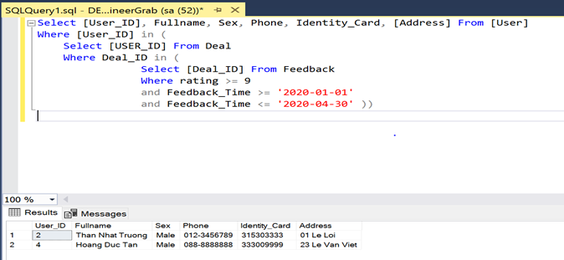

*Figure 53 – Query command 1*

### 3.2 Query command 2

Query commands use to show the list of customers who are eligible for the promotion but have not used the promotion.

(The customers’ information include: USER_ID, Fullname, Sex, Phone, Identity_Card, Address).

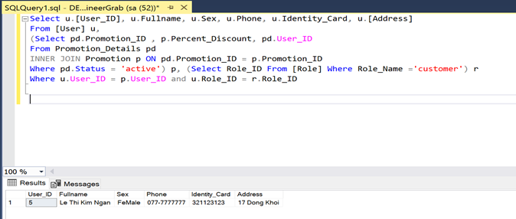

*Figure 54 – Query command 2*

### 3.3 Query command 3

Query commands use to show the list of repair requests from customers name is "Le Thi Kim Ngan".

(The customer’s information includes: title, content, created-time, requestor_Name, Requestor_Address, Request_Time, service_Name).

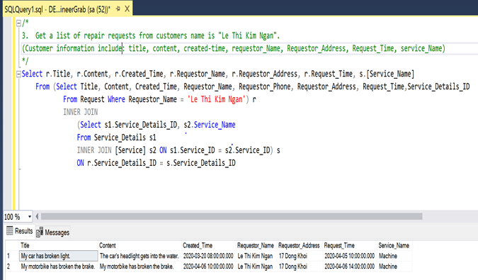

*Figure 55 – Query command 3*

### 3.4 Query command 4

Query commands use to show the list of areas with the most customer in HCM City.

(The areas’ information include: District_ID, District_Name, NumberOfUser)

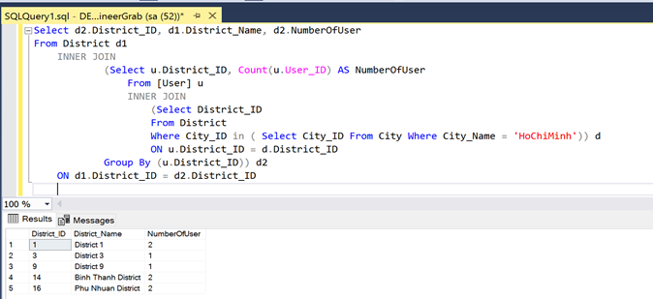

*Figure 56 – Query command 4*

### 3.5 Query command 5

Query commands use to show the list of accounts is not activated.

(The accounts’ information include: USER_ID, Fullname, Sex, Phone, Identity_Card, Email).

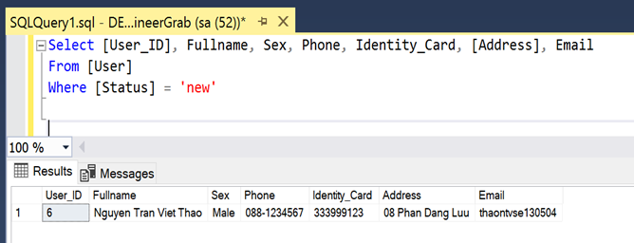

*Figure 57 – Query command 5*

# D. Survey information

## Customer survey

**Link to the customer survey form:** <https://docs.google.com/forms/d/1yR75Qs7M1HVNjyZfeRPFKl_Teol3T_QIM-nA7-Mdtt4/edit>

**Survey results:**

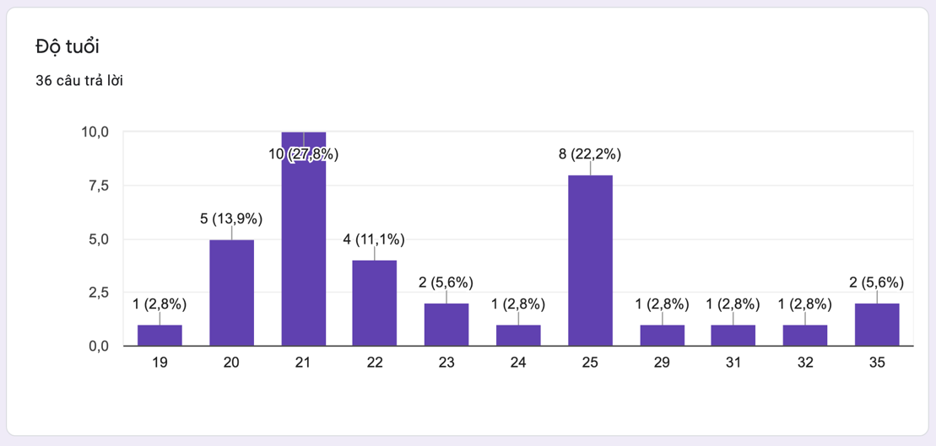

*Figure 58 – Survey Customer 1*

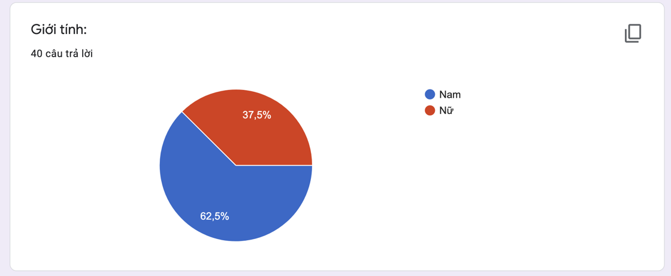

*Figure 59 – Survey Customer 2*

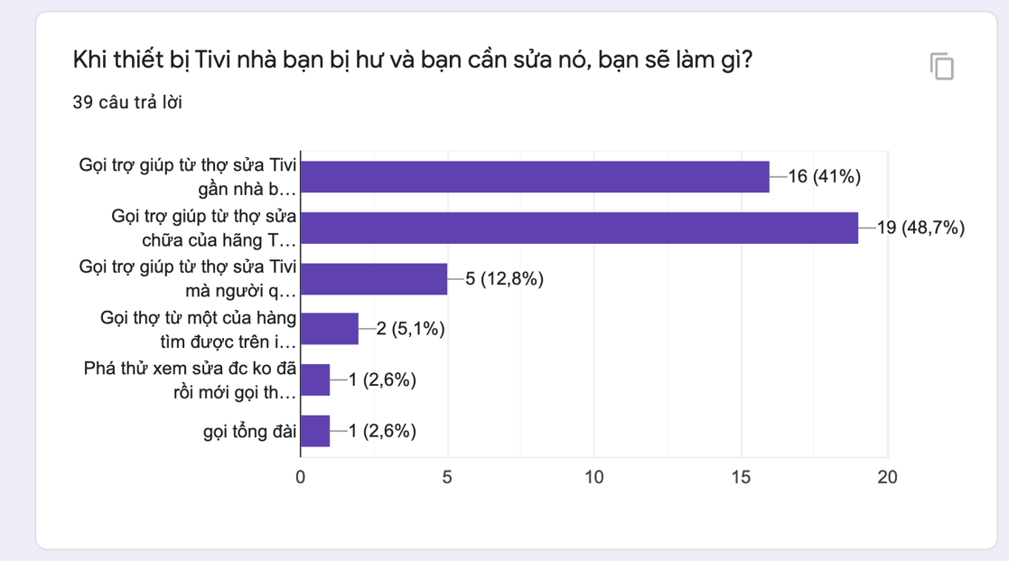

*Figure 60 – Survey Customer 3*

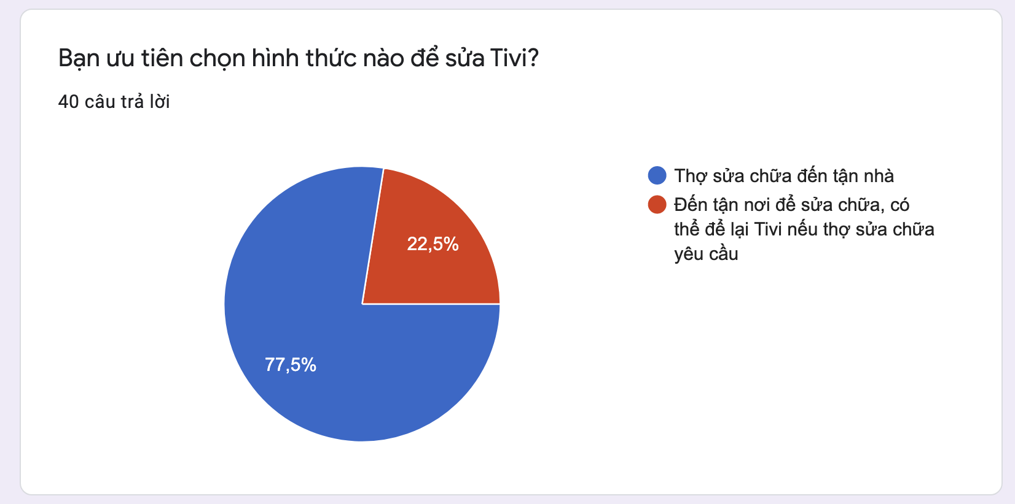

*Figure 61 – Survey Customer 4*

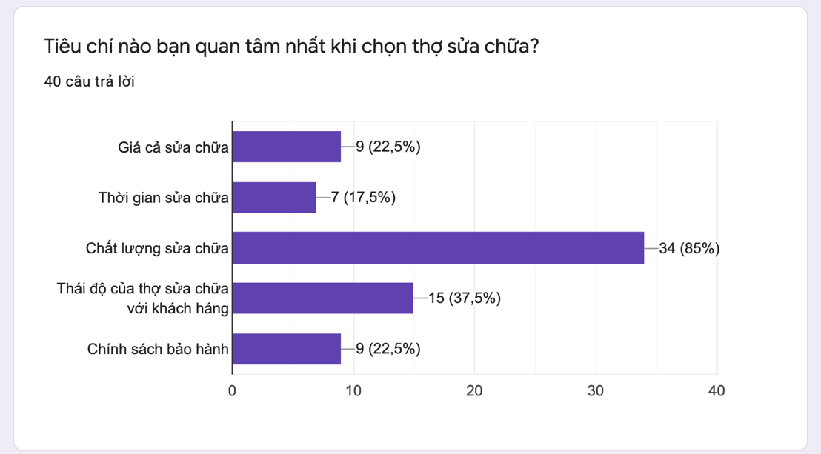

*Figure 62 – Survey Customer 5*

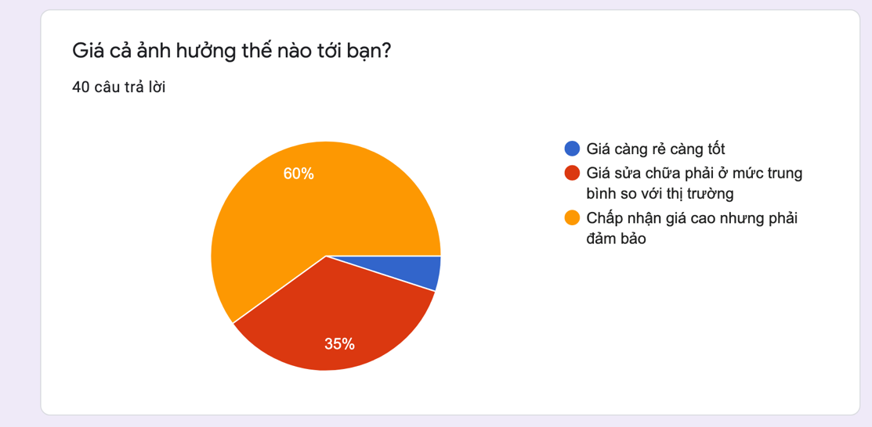

*Figure 63 – Survey Customer 6*

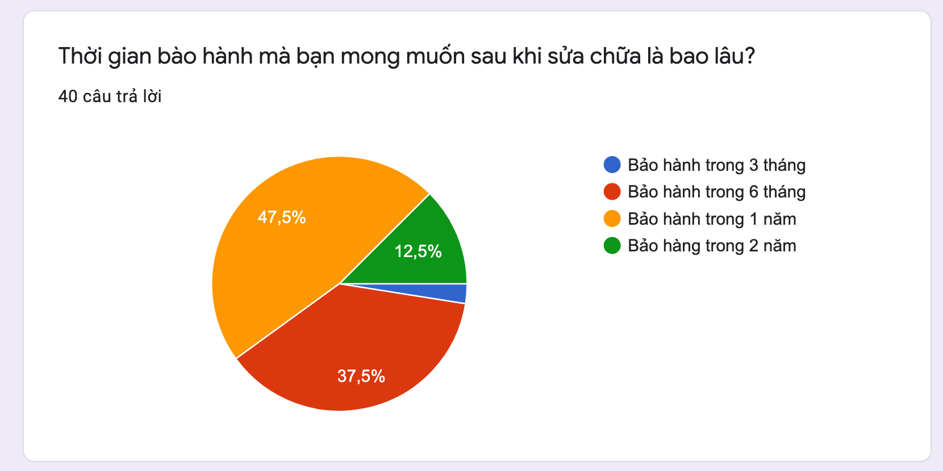

*Figure 64 – Survey Customer 7*

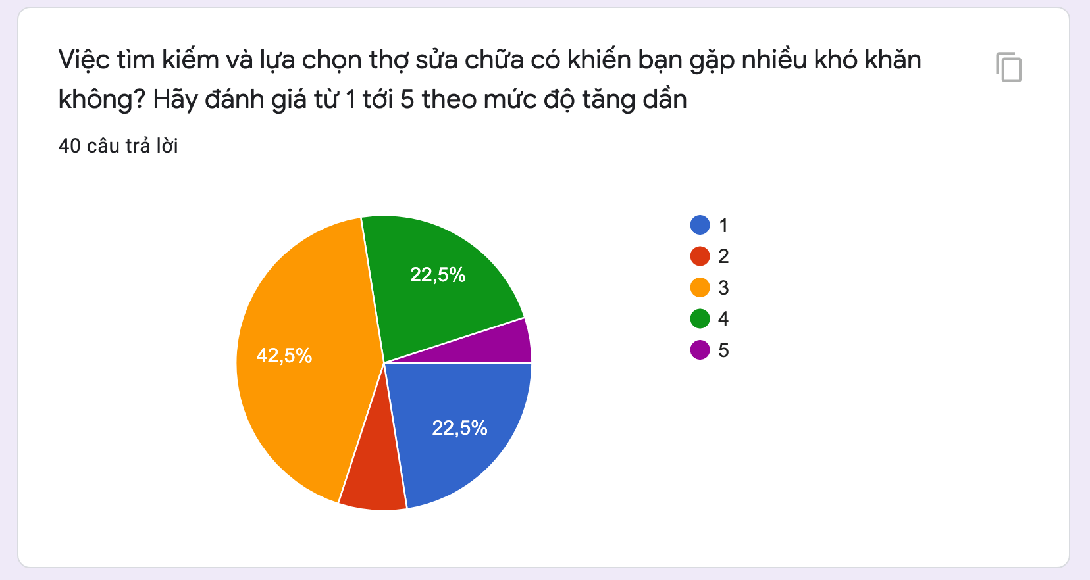

*Figure 65 – Survey Customer 8*



*Figure 66 – Survey Customer 9*

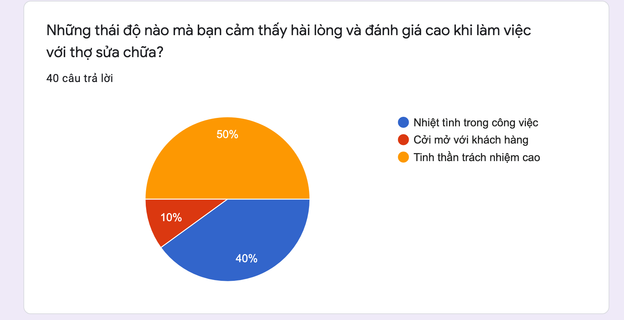

*Figure 67 – Survey Customer 10*

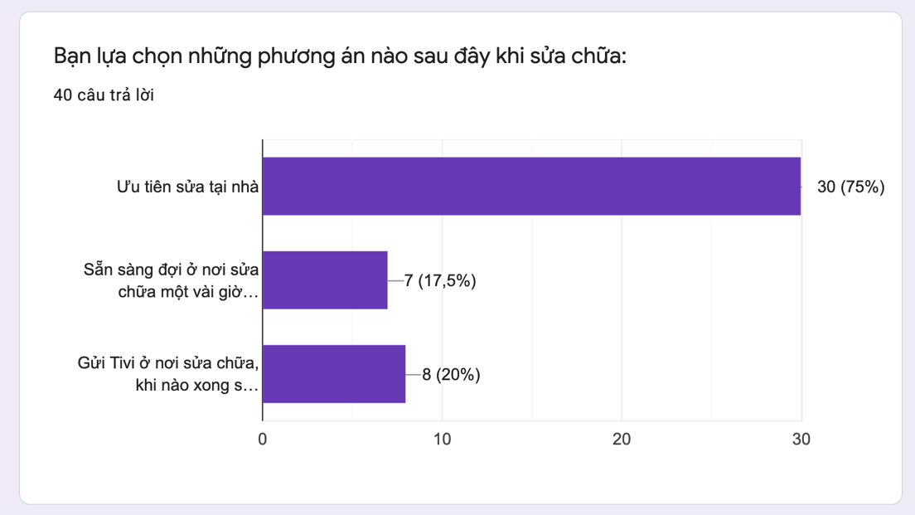

*Figure 68 – Survey Customer 11*

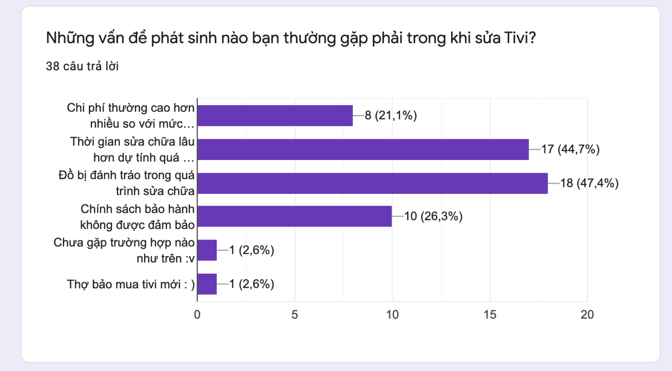

*Figure 69 – Survey Customer 12*

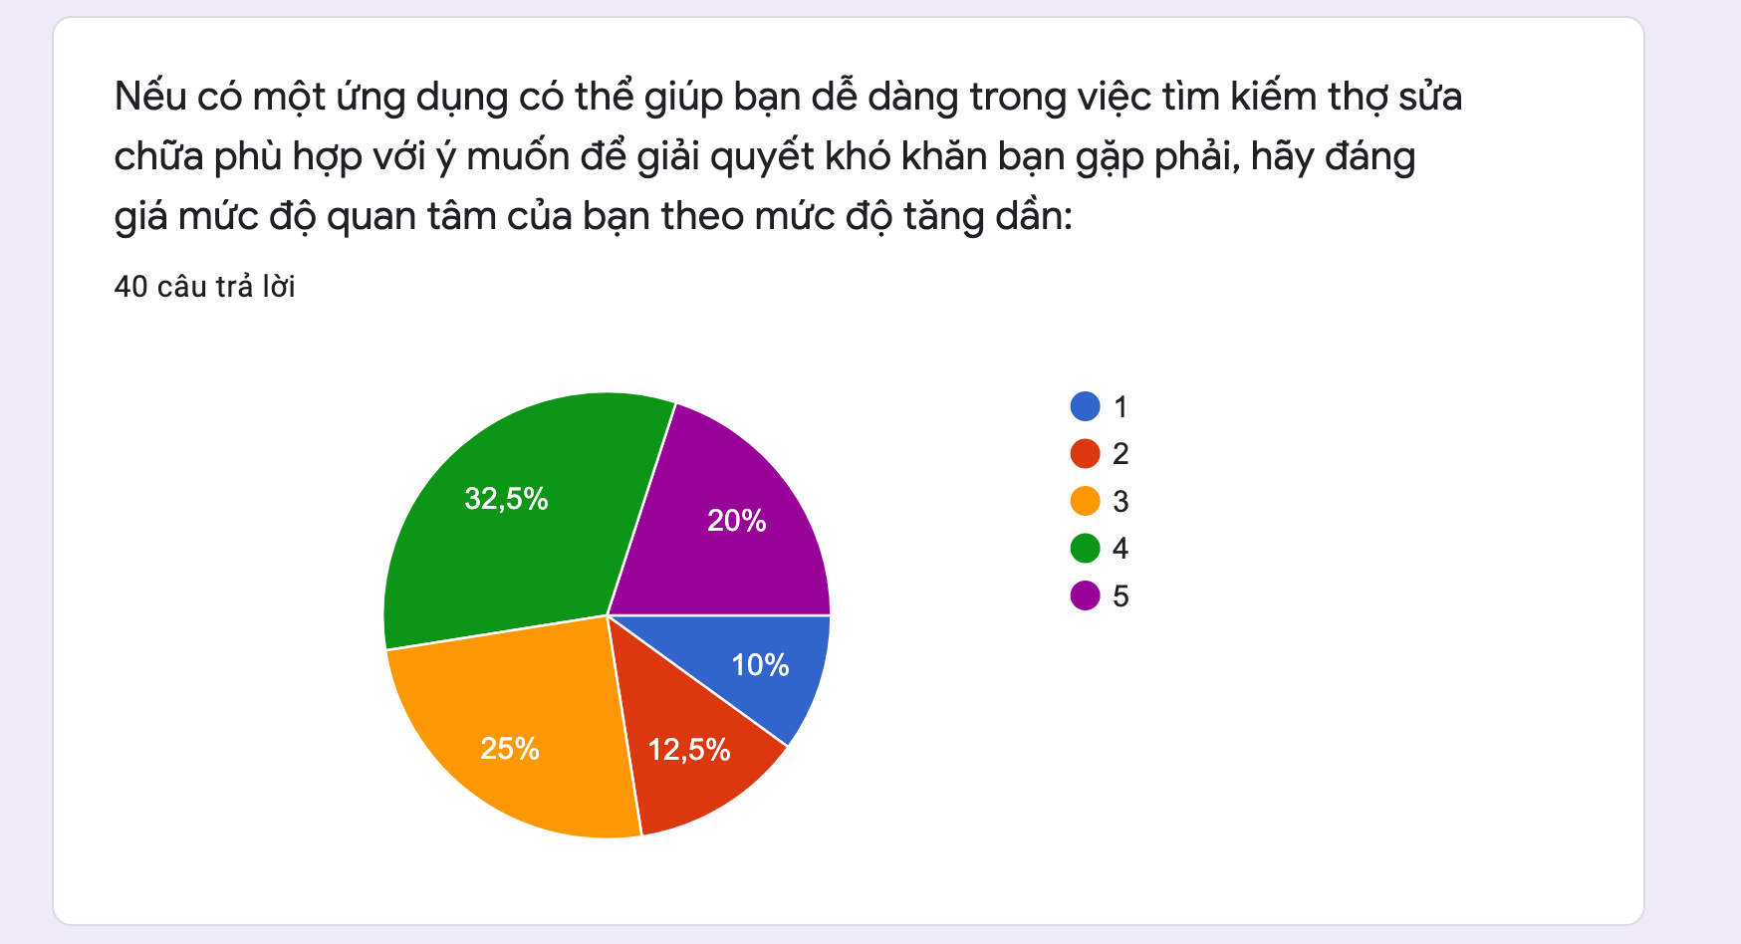

*Figure 70 – Survey Customer 13*

## Engineer survey

**Link to the engineer survey form:** [https://docs.google.com/forms/d/1v-n5-kPYoHOs071aUZBPxDxz-hx6HWck29oasSomamE/edit](https://meet.google.com/linkredirect?authuser=2&dest=https%3A%2F%2Fdocs.google.com%2Fforms%2Fd%2F1v-n5-kPYoHOs071aUZBPxDxz-hx6HWck29oasSomamE%2Fedit)

**Survey result:**

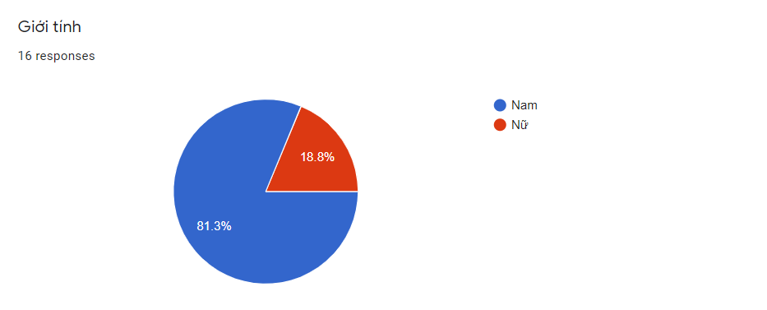

*Figure 71 – Survey Engineer 1*

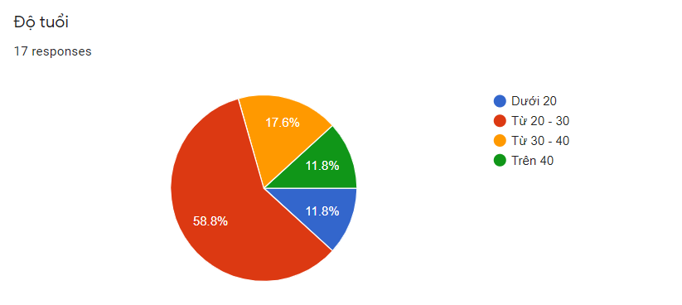

*Figure 72 – Survey Engineer 2*

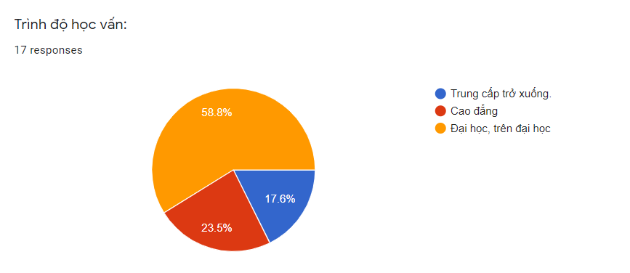

*Figure 73 – Survey Engineer 3*

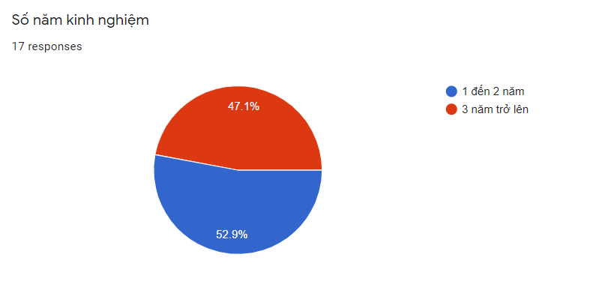

*Figure 74 – Survey Engineer 4*

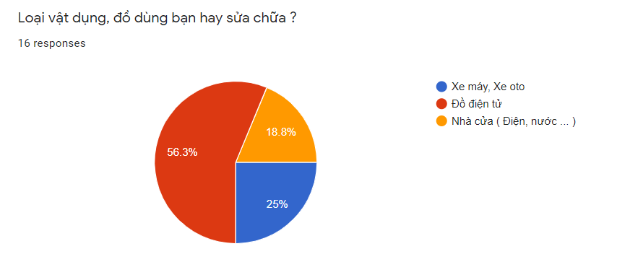

*Figure 75 – Survey Engineer 5*

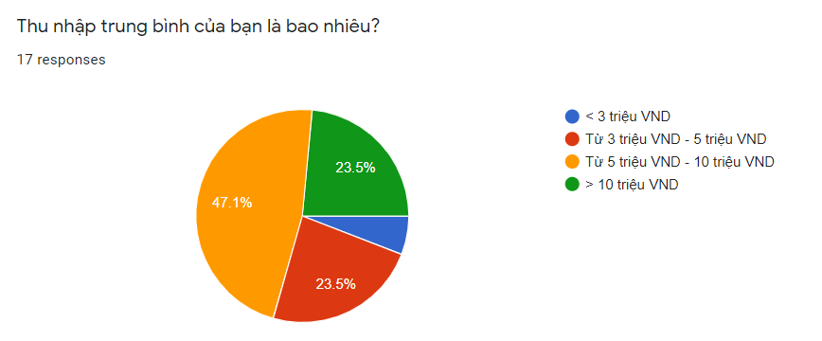

*Figure 76 – Survey Engineer 6*

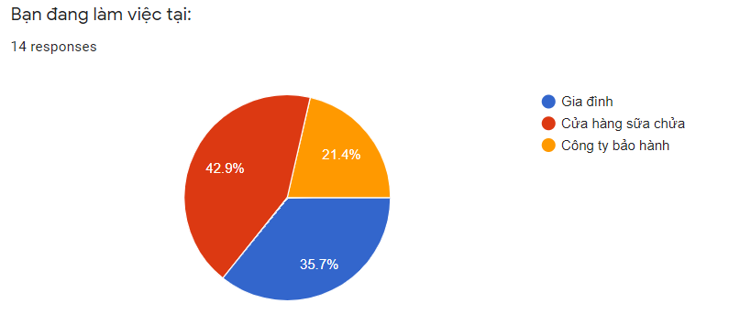

*Figure 77 – Survey Engineer 7*

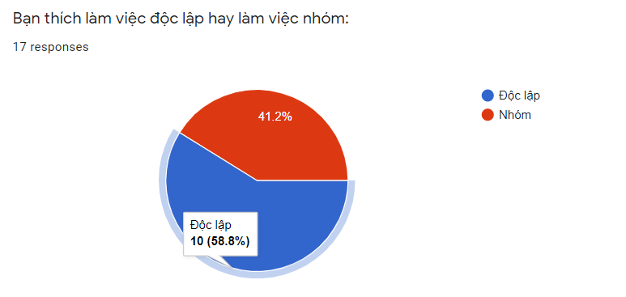

*Figure 78 – Survey Engineer 8*

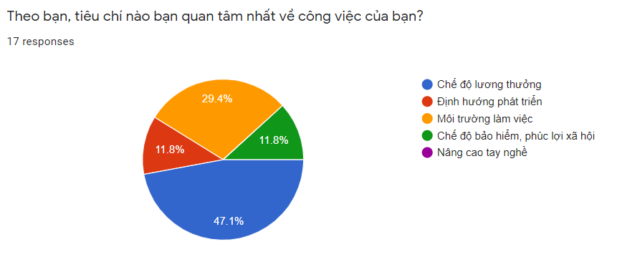

*Figure 79 – Survey Engineer 9*

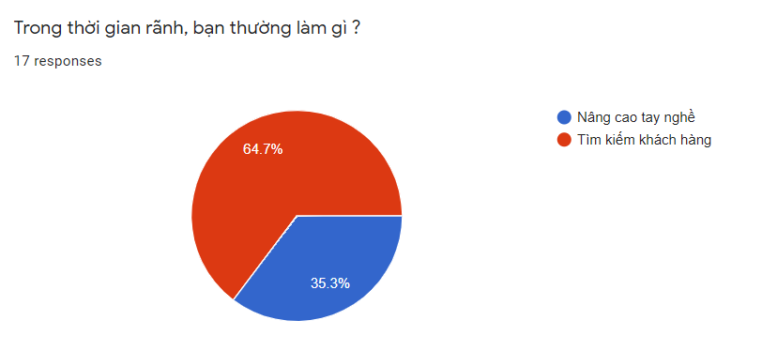

*Figure 80 – Survey Engineer 10*

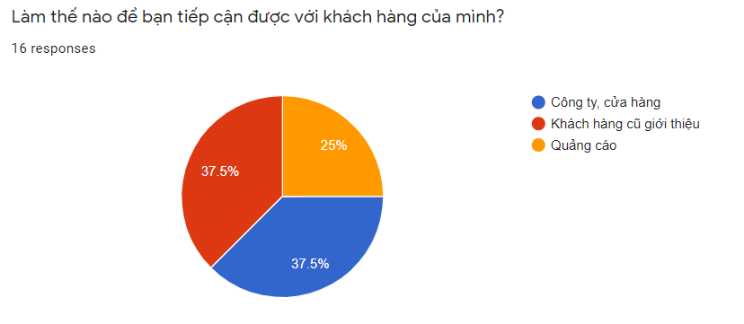

*Figure 81 – Survey Engineer 11*

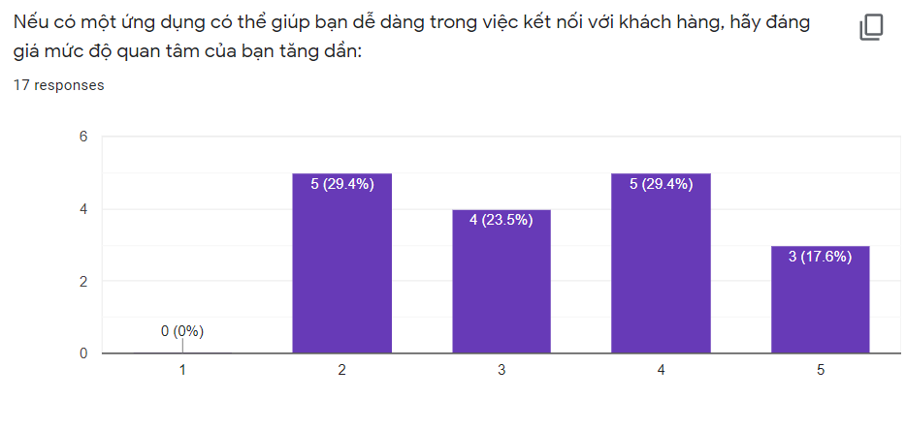

*Figure 82 – Survey Engineer 12*